

**Pizza Delivery App**

**NAAN MUDHALVAN**

**PROJECT REPORT**

Submitted by

|  |  |
| --- | --- |
| **GAYATHRI. N** | **(au620120104021)** |
| **GAYATHRI. S** | **(au620120104022)** |
| **ISHWARYA. M** | **(au620120104035)** |
| **KAVIYA. B** | **(au620120104047)** |

*In partial fulfillment of the award of the degree* of

**BACHELOR OF ENGINEERING**

*in*

**COMPUTER SCIENCE AND ENGINEERING**

**AVS ENGINEERING COLLEGE**

**AMMAPET, SALEM- 636 003**

**ANNA UNIVERSITY :: CHENNAI 600 025**

**BONAFIDE CERTIFICATE**

Certified that this project report **“Pizza Delivery App”** is the bonafide work of **“GAYATHRI. N(au620120104021),GAYATHRI. S(au620120104022), ISHWARYA. M(au620120104035), KAVIYA. B(au620120104047)”** who carried out the project work under my supervision.

|  |  |
| --- | --- |
| **SIGNATURE** | **SIGNATURE** |
| **HEAD OF THE DEPARTMENT**  **Prof. V. Meena, M.E.,** | **PROJECT SUPERVISOR**  **Mr. G. ArokiaNathan, M.E.,** |
| Assistant Professor,  Department of CSE,  AVS Engineering College,  Salem- 636003. | Assistant Professor,  Department of CSE,  AVS Engineering College,  Salem- 636003. |
| -------------------------------------------  **SPOC** | ------------------------------------------  **HEAD OF THE DEPARTMENT** |

**ACKNOWLEDGEMENT**

We would like to express our gratitude and appreciation to all those who gave us the possibility to complete this report. We would like to acknowledge with much appreciation to our honorable Chairman, **Shri.K.KAILASAM**, Secretary, **Shri.K.RAJAVINAYAKAM,MBA.,** and also to our Correspondent, **Shri.K.SENTHILKUMAR,B.Tech.,** for providing all necessary facilities for the successful completion of the project.

We have immense pleasure in expressing our gratitude to our beloved Principal, **Dr.J.SUNDARARAJAN,M.E,Ph.D.,** for allowing us to have extensive use of our college facilities to do this project. It gives us a great sense of pleasure in expressing our gratefulness to our beloved Vice Principal’s, **Dr.R.VISWANATHAN,M.E.,Ph.D.,** and **Dr.D.R.JOSHUA,M.E.,Ph.D.,** for their professional guidance in scheduling the project work to complete on time.

We express our heartiest gratitude to **Dr.M.VILASINI, M.E.,Ph.D.,** Dean R&D and Head of the Department **Prof.V.MEENA,M.E.,** Department of Computer Science and Engineering for her guidance and encouragement throughout the Project Period. We are indebted to our project coordinator **Mr. G. AROKIANATHAN,M.E.,** Assistant Professor for their constant help and excellent direction.

We specially thank all our Teaching and Non-Teaching Staff Members and Lab Technicians of the **Computer Science and Engineering** for their consistent encouragement to do the project work with full interest and zeal. We pay our profound gratitude to the Almighty God for his invisible vigilance and would like to thank our Parents for giving us support, encouragement and guidance throughout the course of our work.

**TABLE OF CONTENTS**

|  |  |  |
| --- | --- | --- |
| **Chapter No** | **Title** | **Page No** |
| 1. | **LIST OF FIGURES**  **PROJECT SPECIFICATION**  1.1 Problem Goals   * 1. Project Scope   2. Problem Statement Definition   3. Problem Statement Definition   4. Empathy Map Canvas   5. **Proposed Solution**   6. Functional & Technical Requirements   7. Project Road Map | **5**  **6**  6  7  8  8  9  11  11  13 |
| 2. | **PREPARATION DATA MODELING**  2.1 Sales force Developer Org  2.2 Object Creation  2.3 Tabs Creation  2.4 The Lightning App  2.5 Fields and Relationship  2.6 Record Types | **15**  16  17  23  23  26  31 |
| 3. | **USERS & DATA SECURITY**  3.1 Profile  3.2 User Adoption& Approval | **32**  35  35 |
| 4. | **AUTOMATION**  4.1 OWD  4.2 Apex Trigger  4.3 Schedule Apex | **36**  36  38  39 |
| 5. | **REPORTS & DASHBOARD**  5.1 Reports | **42** |
| 6. | **CONCLUSION** | **42** |
| 7. | **Project Demonstration**  GitHub& Project Video Demo Link | **46** |

**LIST OF FIGURES**

|  |  |  |
| --- | --- | --- |
| **Figure No** | **Name of Figure** | **Page No** |
| 1.7.1 | Data Flow Diagram | 12 |
| 1.7.2 | Technical Architecture | 13 |

**CHAPTER-1**

**PROJECT SPECIFICATION**

**1.1Project Goal**

The primary goal of the Pizza Delivery App project is to provide a convenient, efficient, and enjoyable experience for customers while ordering pizzas. The app aims to offering a seamless process from menu selection to doorstep delivery. Here are the primary objectives of a pizza delivery app:

### 1. Convenience for Customers:

Objective: Provide users with a hassle-free way to order their favorite pizzas from the comfort of their homes or workplaces.

Key Features: Easy menu navigation, quick order placement, saved preferences, and multiple payment options for a smooth transaction.

### 2. Efficient Order Processing:

Objective: Streamline the ordering process for both customers and the restaurant staff to minimize errors and maximize efficiency.

Key Features: Customization options, real-time order tracking, and integration with the restaurant's kitchen system for accurate preparation.

### 3. Timely and Accurate Deliveries:

**Objective:** Ensure that pizzas are delivered hot and fresh to customers within the promised time frame.

**Key Features:** GPS tracking for real-time delivery updates, optimized delivery routes, and timely notifications to customers about their order status.

### 4. Quality Customer Service:

**Objective:** Provide excellent customer service and support to address queries, concerns, and special requests.

**Key Features:** Customer support chat, hotline assistance, and a user-friendly feedback system to address customer inquiries and feedback promptly.

### 5. Secure Transactions:

**Objective:** Guarantee the security of online transactions and customer data to build trust and confidence among users.

**Key Features:** Secure payment gateways, encryption protocols, and compliance with data protection regulations to protect user privacy and financial information.

This project aims to the app aims to bridge the gap between customers and the pizzeria, offering a seamless process from menu selection to doorstep delivery.

### 1.2Project Scope

The project scope for a pizza delivery app outlines the boundaries, features, functionalities, and deliverables of the app development endeavor. Here's a detailed project scope for a pizza delivery app:

**1**.Introduction and Background:

**Objective:** Provide an overview of the pizza delivery industry, market analysis, and the need for the app.

**Deliverables**: Market research report, user personas, and competitor analysis.

### 2. Features and Functionalities:

**Objective:** Define the specific features and functionalities of the pizza delivery app.

**Key Features:**

* User Registration and Authentication
* Menu Display with Pizza Customization Options
* Cart Management and Order Placement

### 3. Platform and Technology:

**Objective:** Specify the platforms (iOS, Android) and technologies (programming languages, frameworks) the app will be developed on.

**Deliverables:** Cross-platform app compatible with iOS and Android devices, developed using languages like Swift (iOS) and Kotlin/Java (Android) with backend technologies like Node.js or Django.

### 4. User Roles and Permissions:

**Objective:** Define different user roles (customers, delivery drivers, restaurant staff) and their respective permissions.

**Deliverables:** User role matrix outlining access levels and permissions for each role.

### 5. Data Management and Security:

**Objective:** Define how user data will be stored, processed, and secured.

**Deliverables:** Data encryption protocols, compliance with data protection regulations (GDPR, CCPA), and secure storage practices.

Defining a clear project scope is essential to ensure that everyone involved, including developers, stakeholders, and users, have a common understanding of what the app will include.

* 1. **Problem Statement Definition**

|  |  |  |  |
| --- | --- | --- | --- |
| **Problem for** | **Trying to** | **But** | **Which makes** |
| **Employee** | I’m working in a pizza delivery app store, and I'm trying to efficiently manage customer records, process orders, and generate discount coupons for various types of employees. | But the manual and time-consuming nature of these tasks, along with the risk of errors. | This makes me feel overwhelmed and hinders our ability to provide a seamless customer experience. |

* 1. **Empathy Map Canvas**

An empathy map is a simple, easy-to-digest visual that captures knowledge about auser’s behavior and attitudes.

It is a useful tool to helps teams better understand their users. Creating an effective solution requires understanding the true problem and the person who is experiencing it.

The exercise of creating the map helps participants consider things from the user’s perspective along with his or her goals and challenges.

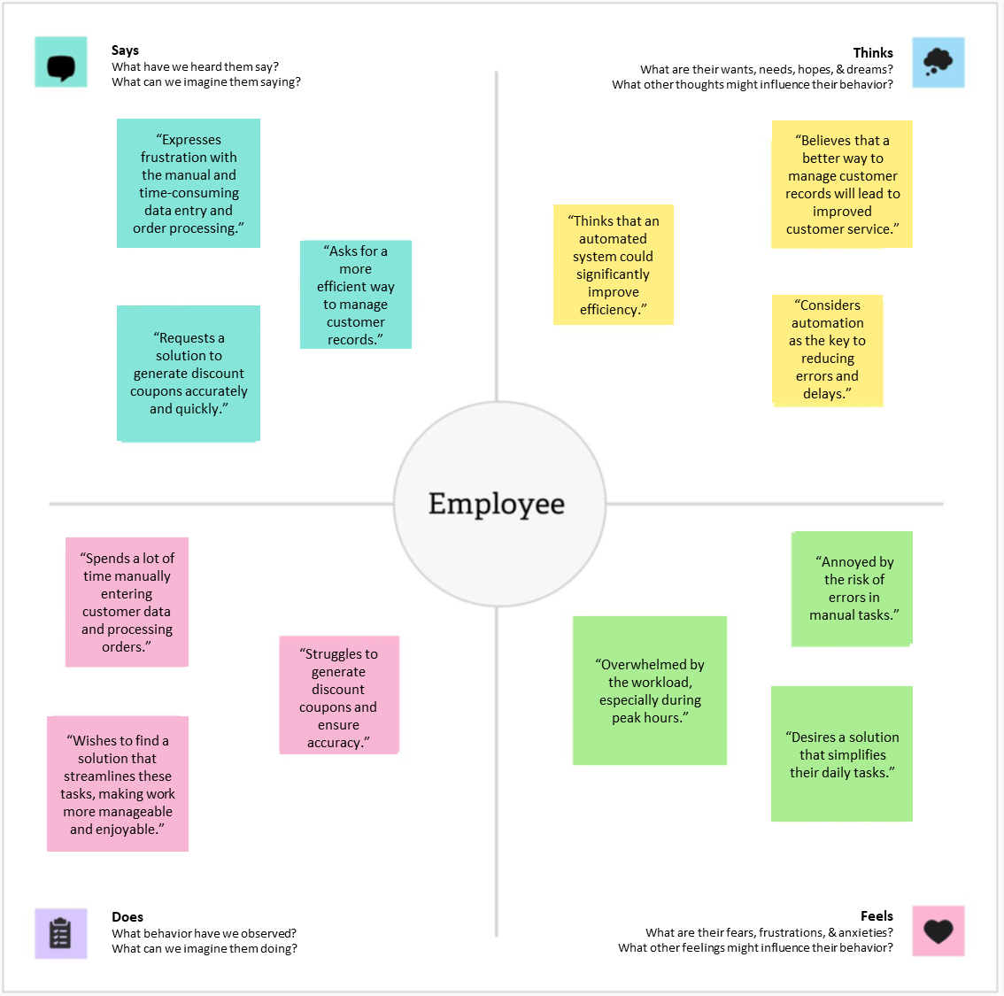

* 1. **Proposed Solution**

|  |  |  |
| --- | --- | --- |
| **S. No** | **Parameter** | **Description** |
| 1. | Problem Statement | The problem to be solved is the manual and time-consuming of customer, order processing, person visits to restaurants often lead to inefficiencies. |
| 2. | Idea / Solution Description | By developing a pizza delivery app that addresses these issues, we aim to revolutionize the way customers interact with pizzerias, providing them with a convenient and enjoyable dining experience while helping restaurants optimize their services and expand their customer base.  Top of Form |
| 3. | Novelty / Uniqueness | The uniqueness of a pizza delivery app lies in its ability to offer a seamless and enjoyable experience for both customers and restaurant owners. |
| 4. | Social Impact / Customer Satisfaction | Customer satisfaction for a pizza delivery app is crucial for retaining customers, fostering loyalty, and generating positive word-of-mouth referrals. To ensure high customer satisfaction, the pizza delivery app should focus on the following aspects:.   * User friendly * Efficient ordering processing * **Accurate and Customizable Orders** |

* 1. **Functional & Technical Requirements**
     1. Functional Requirements

|  |  |
| --- | --- |
| **Requirement** | **Description** |
| **Custom Object Creation** | Create custom objects for "Our Customers," "Consultants," "Retailers," and "Others" to manage customer data, order details, and employee information. |
| **User Profiles and Roles** | Set up user profiles and roles to control access and permissions for different user groups, including "Store Head" and "Billing Operator." |
| **Automation** | Implement automation using triggers, flows, and approval processes to automate coupon generation, data validation, and record updates. |
| **Reports and Dashboards** | Develop various report types, including tabular, summary, and matrix reports, to provide insights into customer data, product sales, and financial performance. Create dashboards for data visualization. |
| **Data Modeling** | Design the data model with relationships between objects to enable efficient data management, allowing the creation of customer records, order details, and coupon management. |

* + 1. Technical Requirements

|  |  |
| --- | --- |
| **Requirement** | **Description** |
| **Salesforce Developer Org** | Create a Salesforce developer org for project development and testing. |
| **Lightning App** | Create a Lightning app to brand the application and provide a customized color scheme and logo. |
| **Automation Tools** | Use Apex triggers and flows to implement automation in the system. |
| **Security and Access Control** | Configure security settings using user profiles, roles, and sharing rules to control access to sensitive data. |
| **User Training** | Provide user training and documentation for effective adoption of the Salesforce system within the cosmetics store. |

**1.7 Project Road Map**

1.7.1 Data Flow Diagram

A Data Flow Diagram (DFD) is a traditional visual representation of the information flows within a system. A neat and clear DFD can depict the right amount of the system requirement graphically. It shows how data enters and leaves the system, what changes the information, and where data is stored.

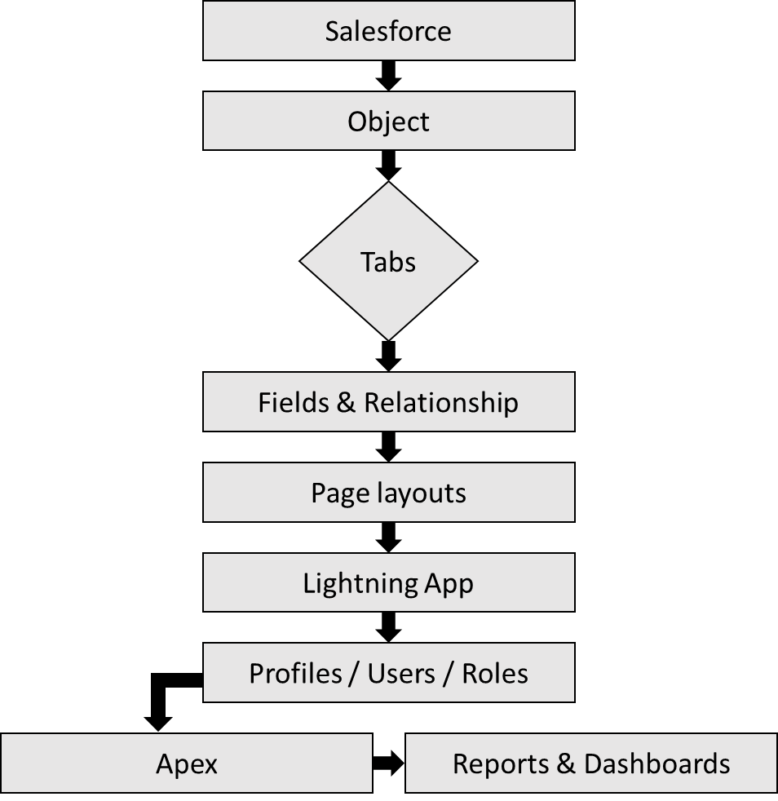

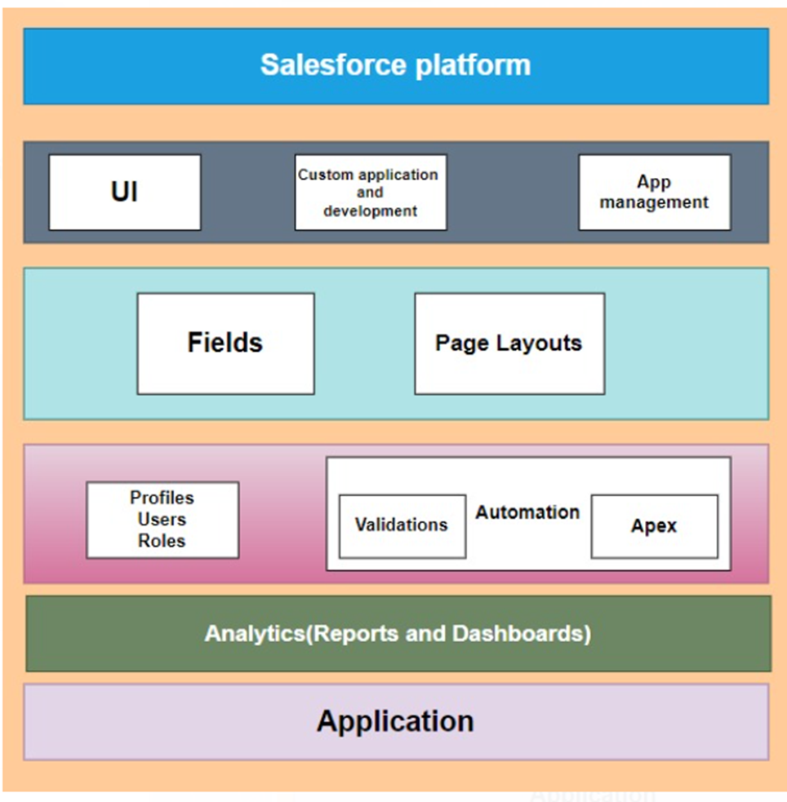1.7.2 Technical Architecture

**CHAPTER-2**

**PREPARATION DATA MODELING**

**2.1 Sales force Developer Org**

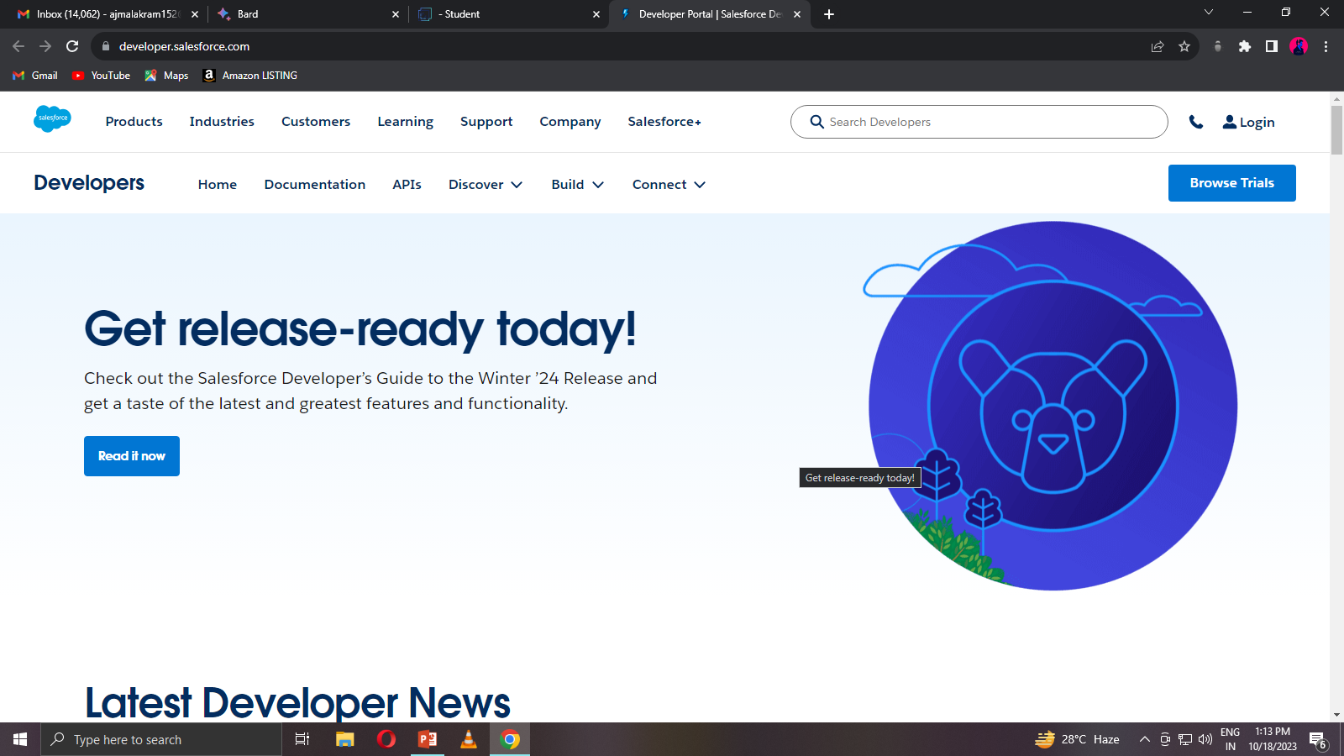In Sales force, a Developer Sign Up or Developer Edition is a special type of Sales force environment that is primarily used for development, testing, and learning purposes.

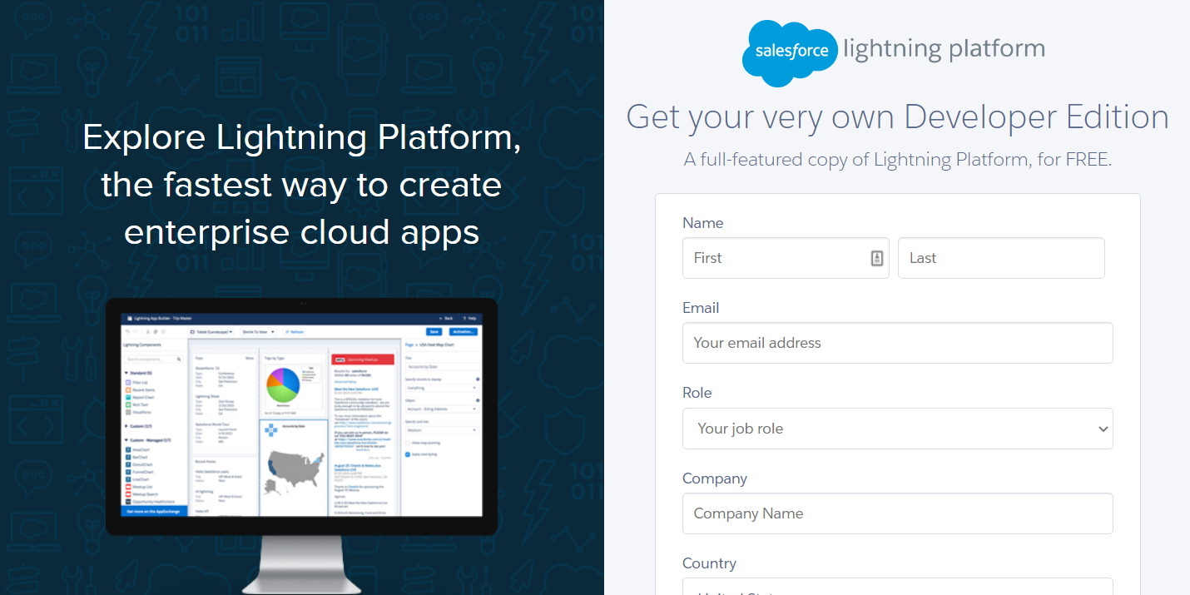

**Account Activation**

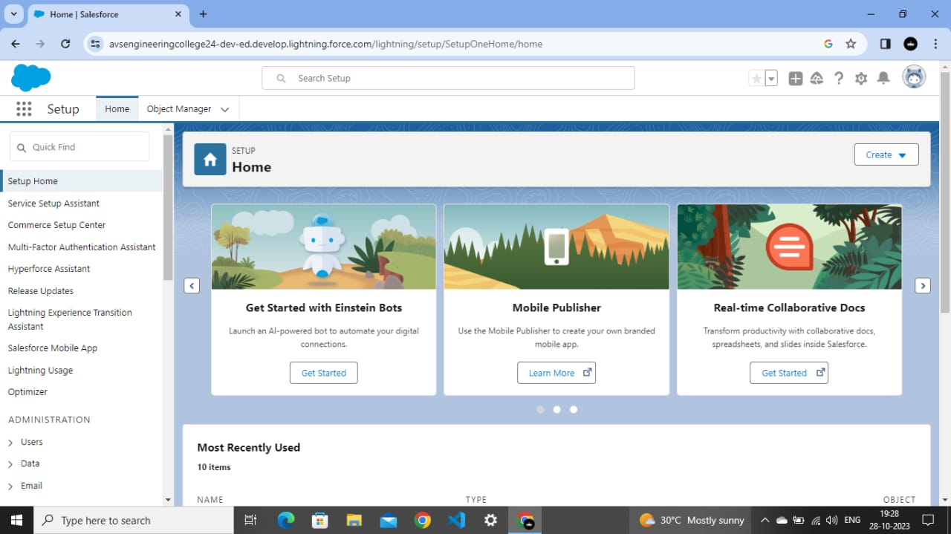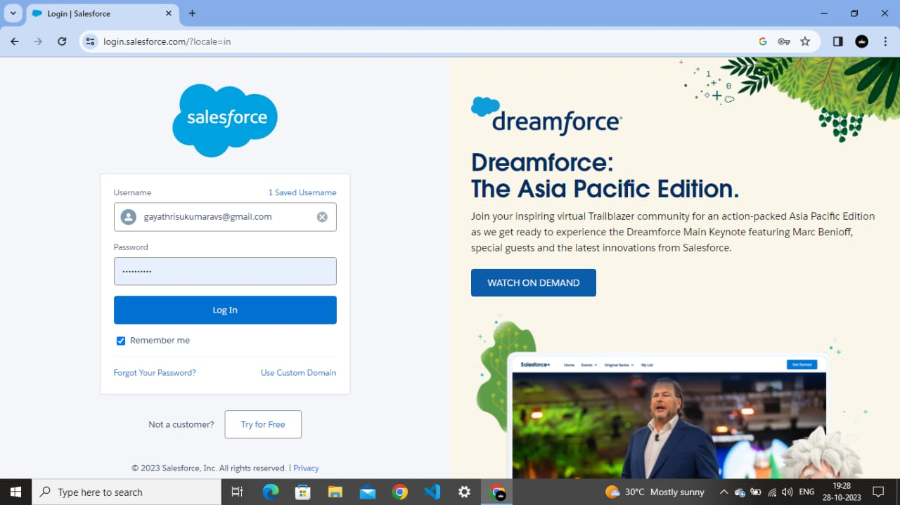Activation tracks information about devices from which users have verified their identity.

**2.2 Object Creation**

Sales force objects are database tables that permit you to store data that is specific to an organization. Sales force objects are of two types: Standard Objects: Standard objects are the kind of objects that are provided by salesforce.com such as users, contracts, reports, dashboards, etc. Custom objects: Our_Customers, Consultants, Retailers, Others.

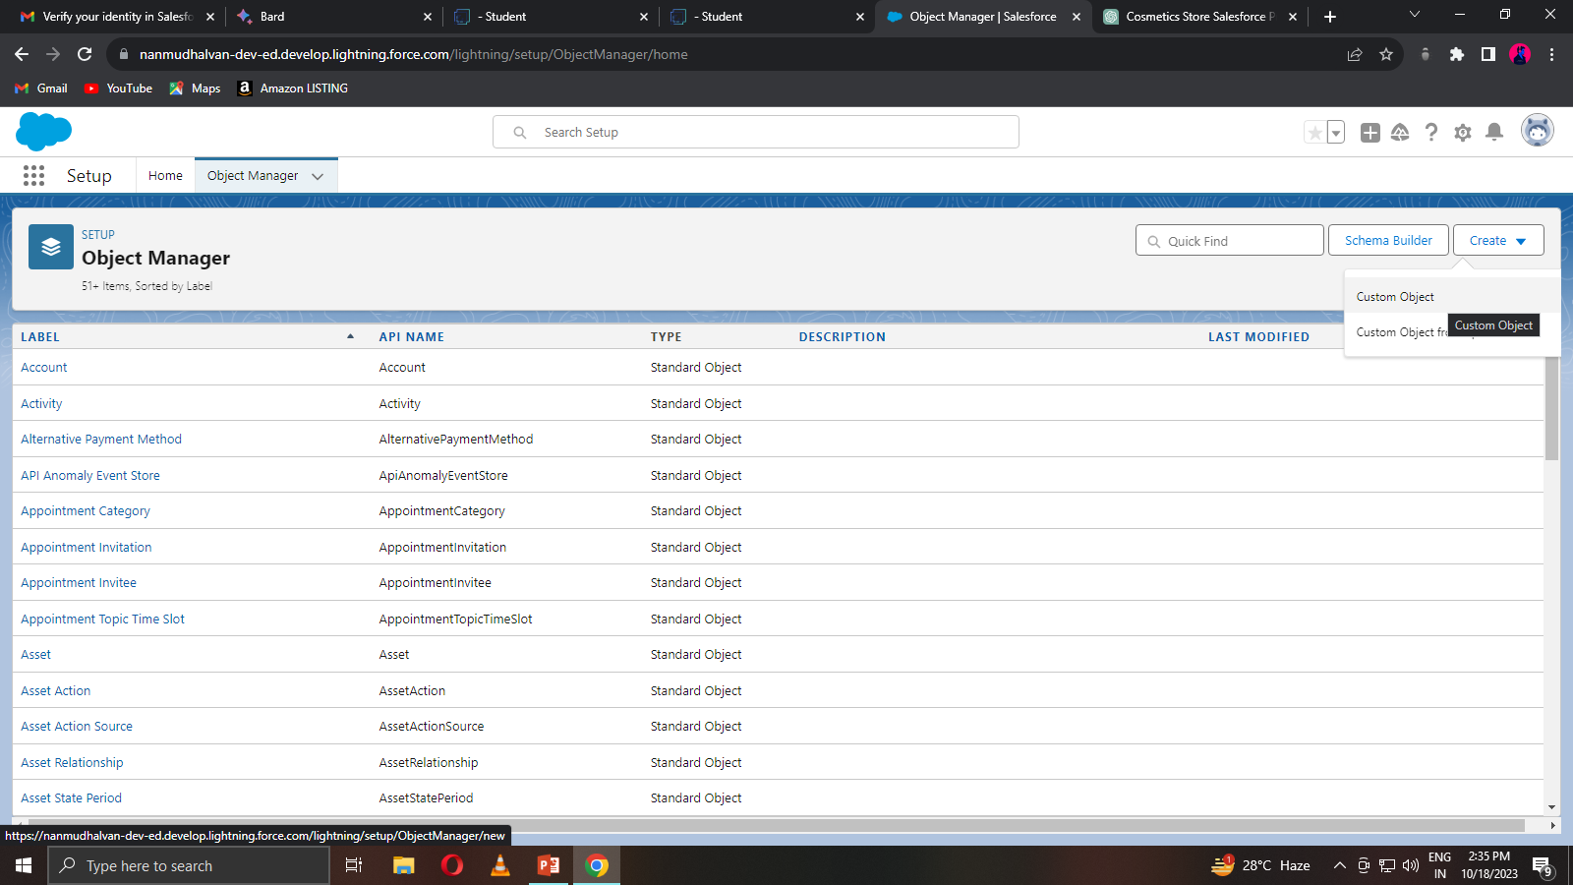**Create the Consultants Object**

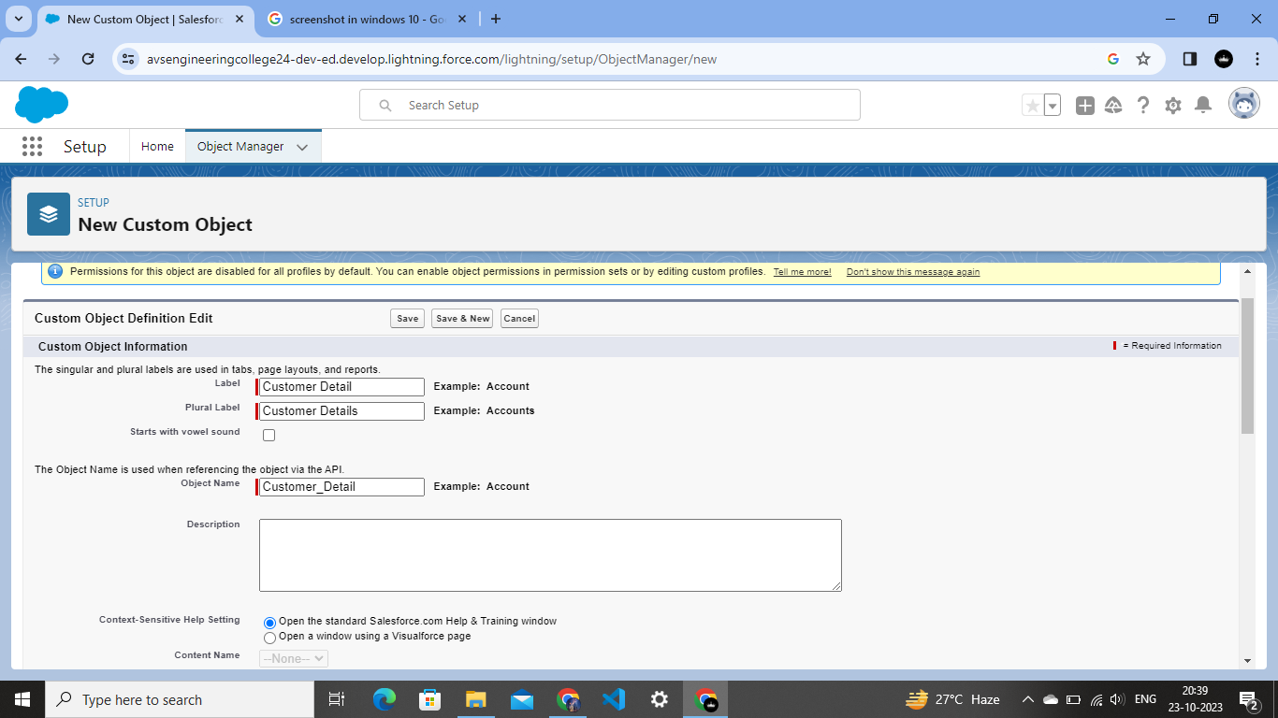**Create the Detail Object**

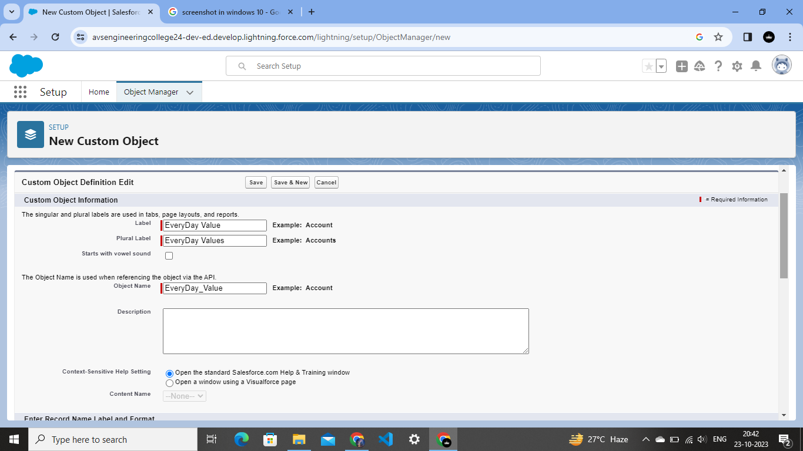

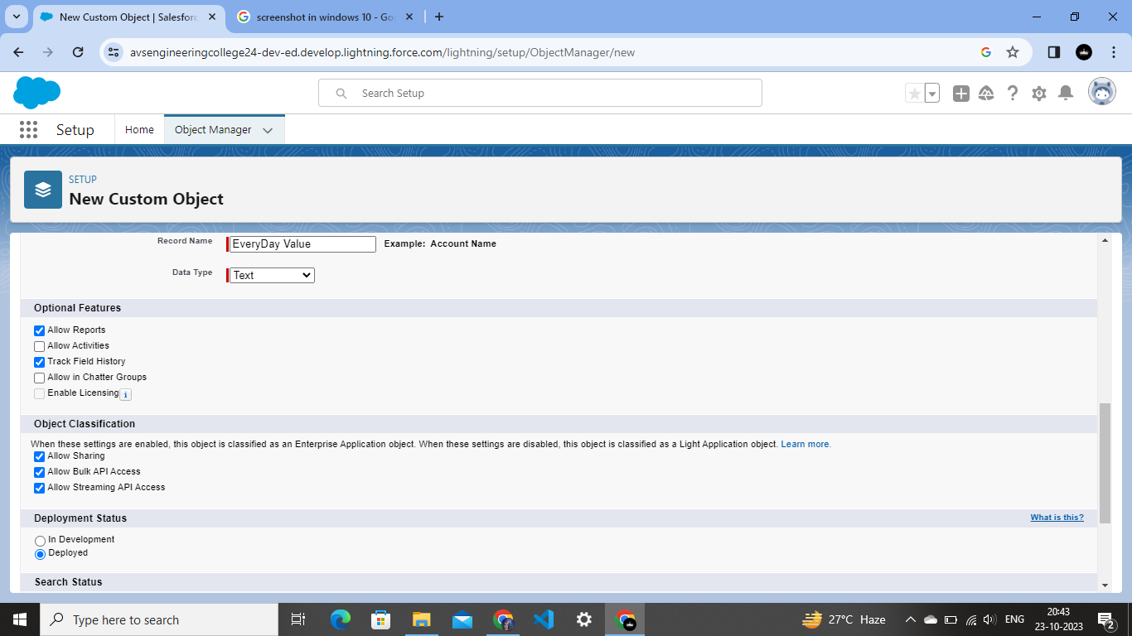

**Go to the Details**

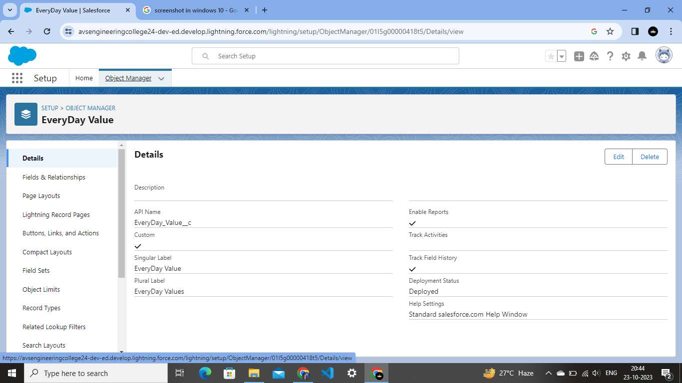

**Create new custom object as Best Seller**

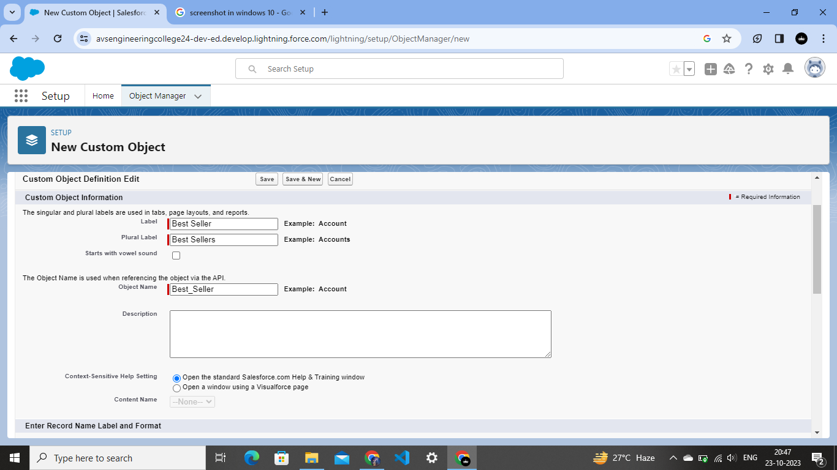

**Another object named as New Launch**

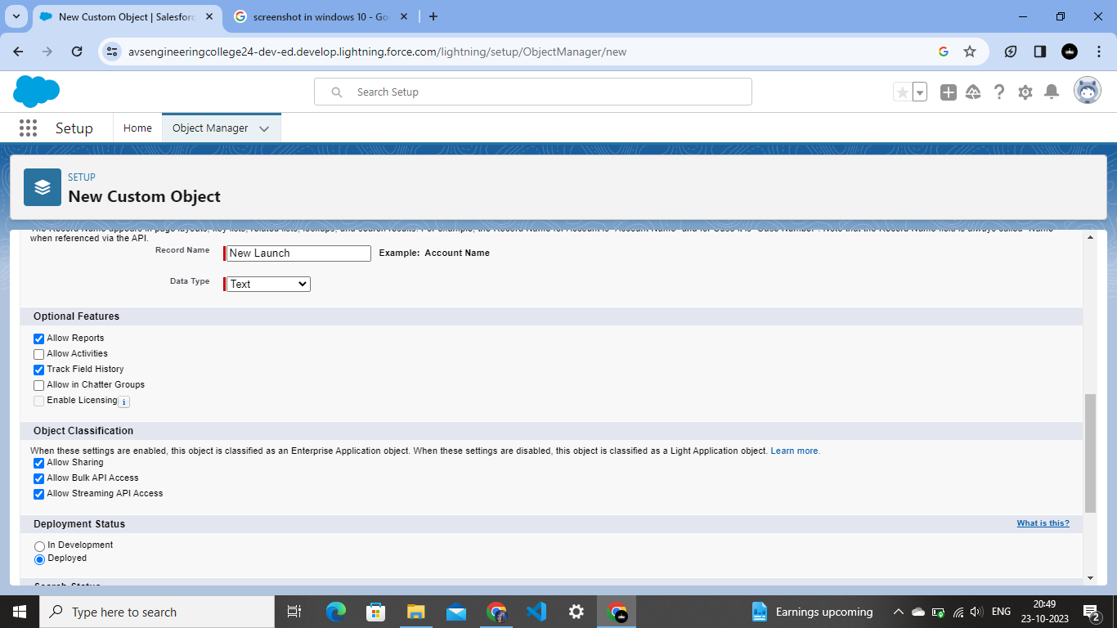



**Create a object known as Pizza**

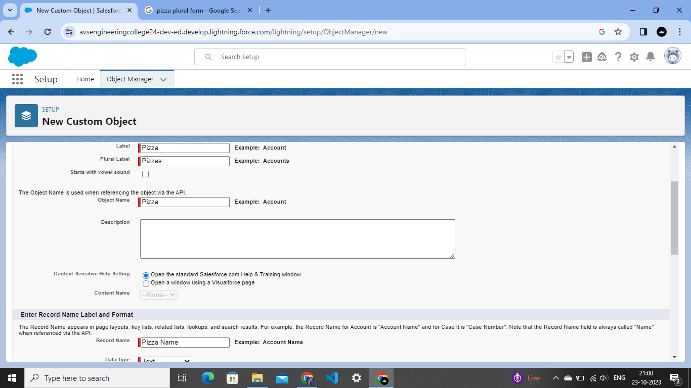

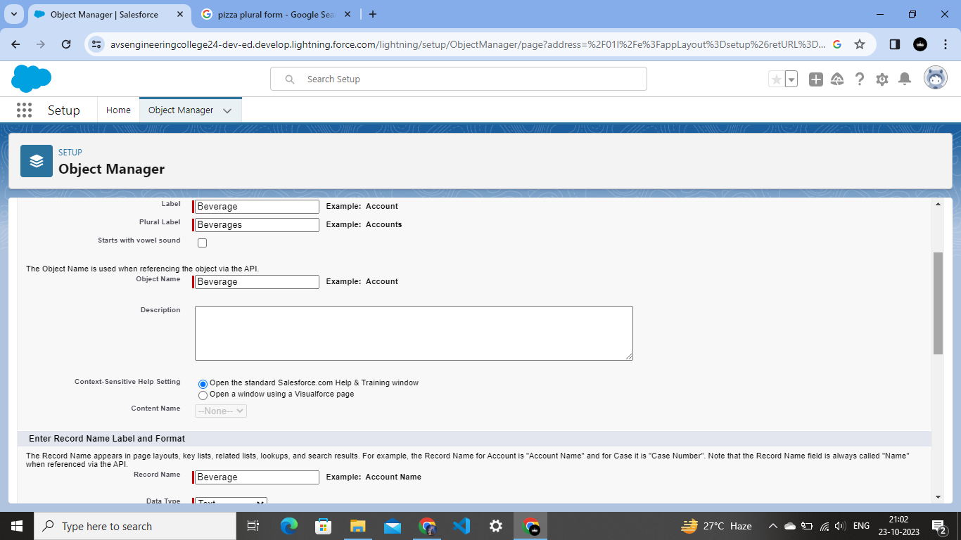

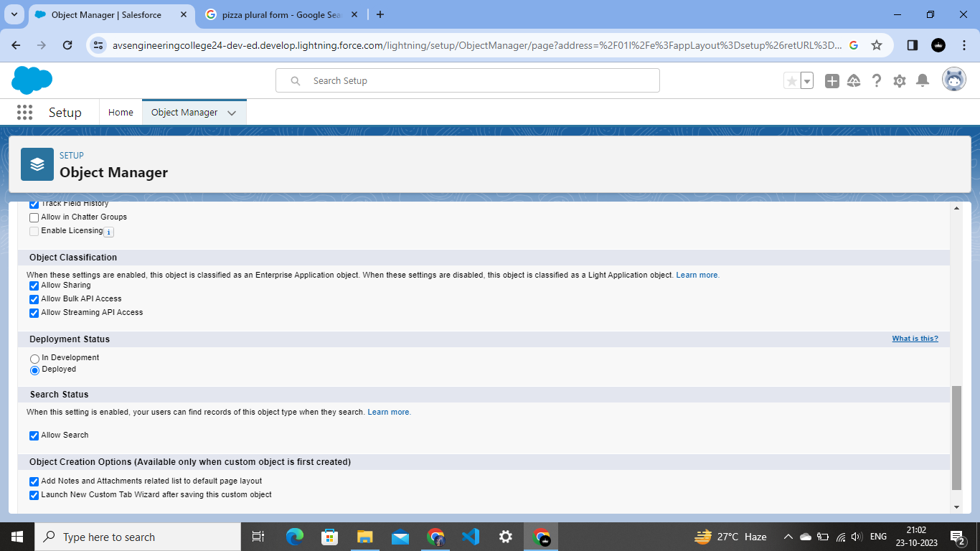

**2.3 Tabs Creation**

In Sales force, a tab is a user interface element that allows users to navigate to different sections of the platform, such as Accounts, Contacts, Leads, and Opportunities.

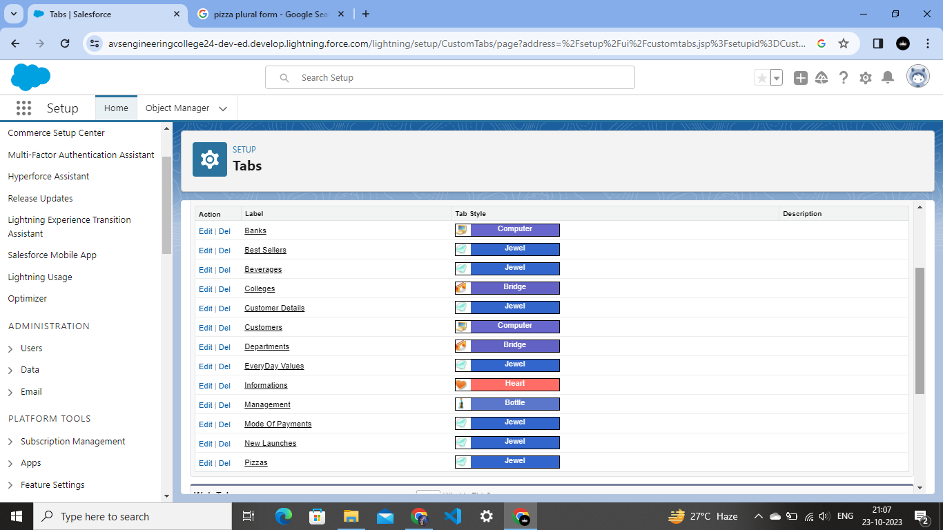

**2.4 The Lightning App**

An app is a collection of items that work together to serve a particular function. In Lightning Experience, Lightning apps give your users access to sets of objects, tabs, and other items all in one convenient bundle in the navigation bar. Lightning apps let you brand your apps with a custom Color and logo. You can even include a utility bar and Lightning page tabs in your Lightning app.

**To create a lightning app page**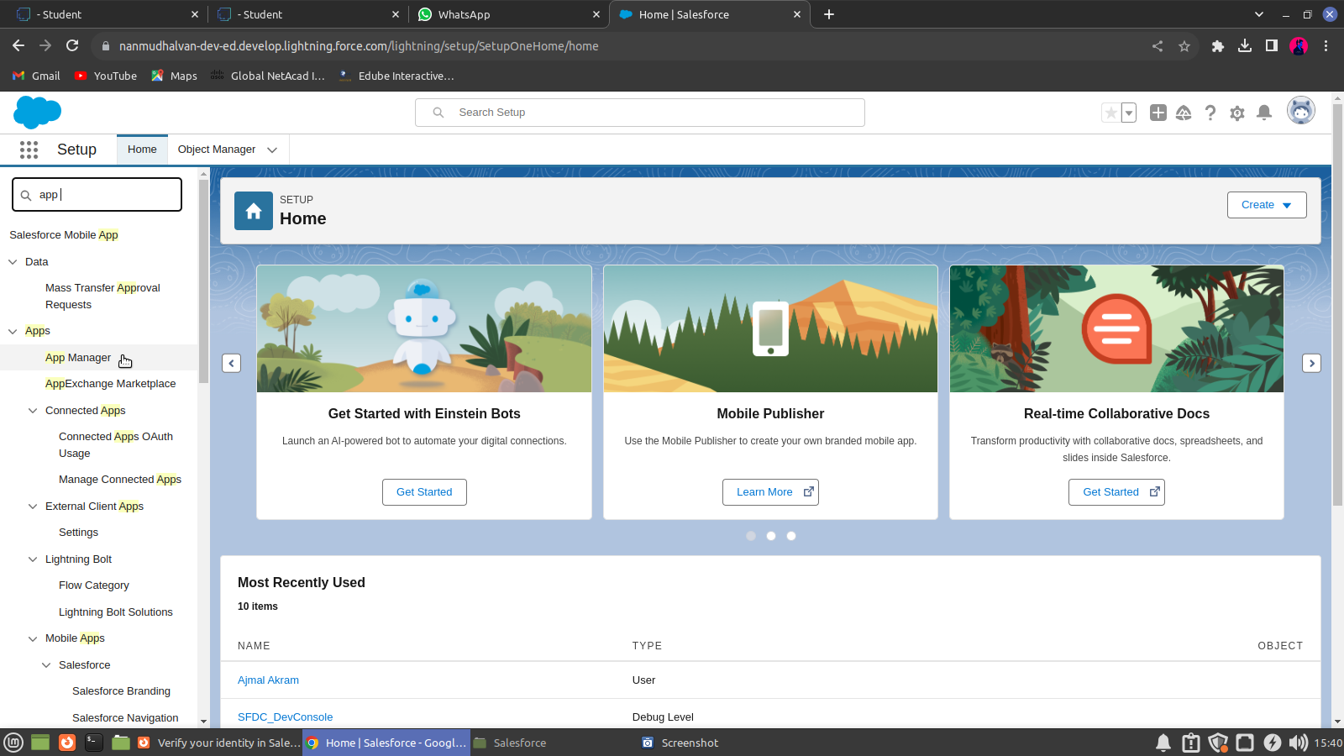

**Fill the app name as an Pizza Delivery in app details and branding**

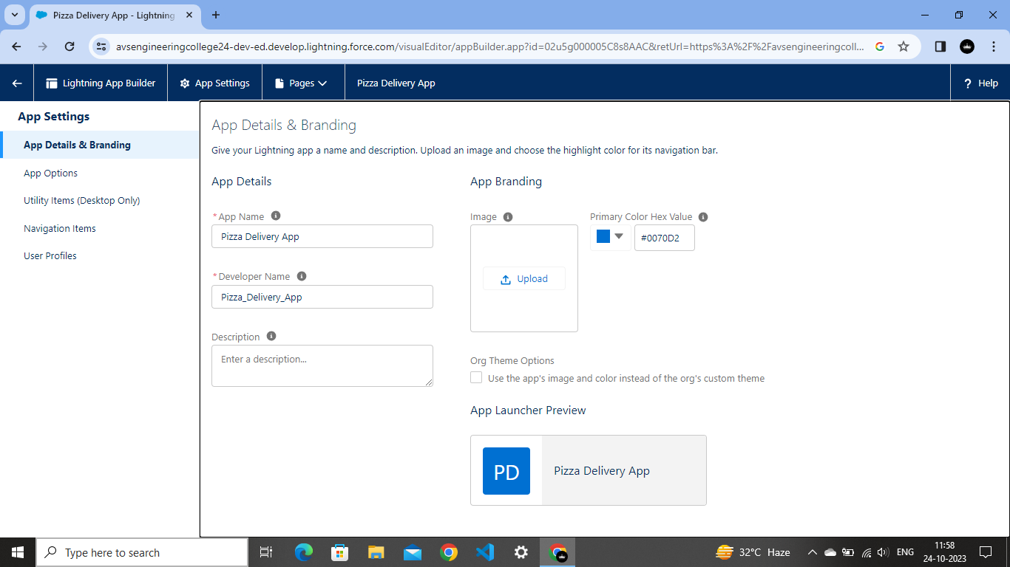

**Click on the Navigation Items**

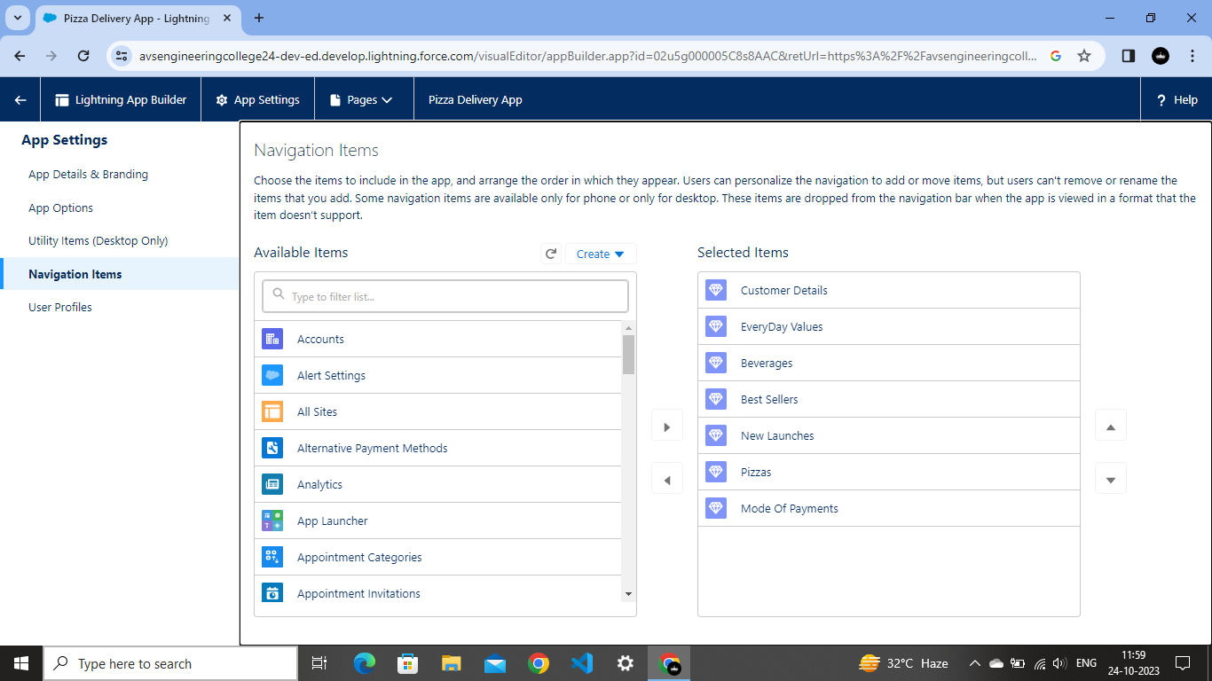

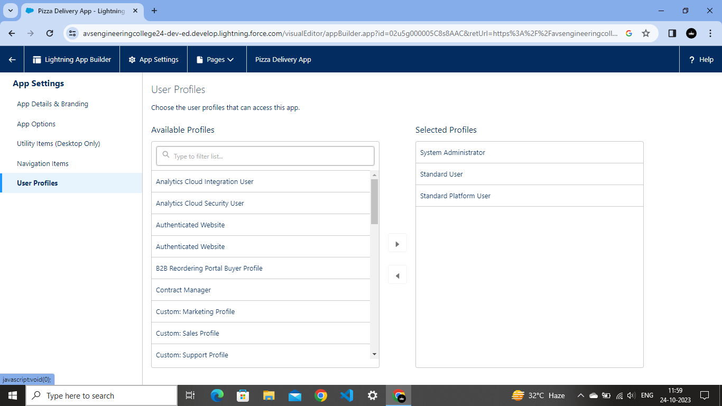

**2.5 Fields and Relationship**

An object relationship in Sales force is a two-way association between two objects. Relationships are created by creating custom relationship fields on an object. This is done so that when users view records, they can also see and access related data.

**Create the Field name as Delivery**

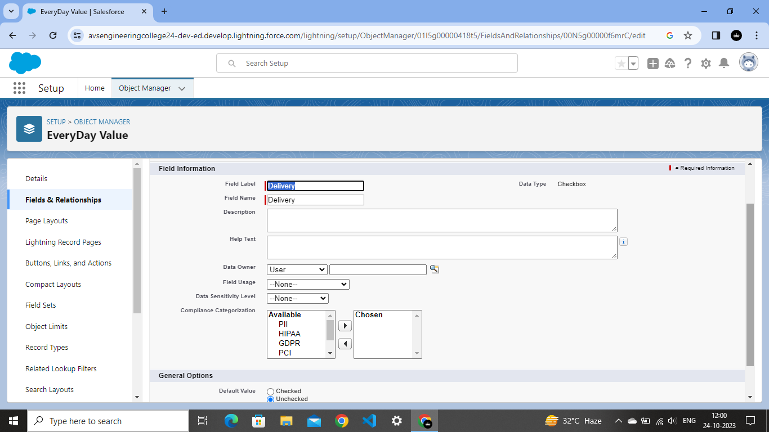

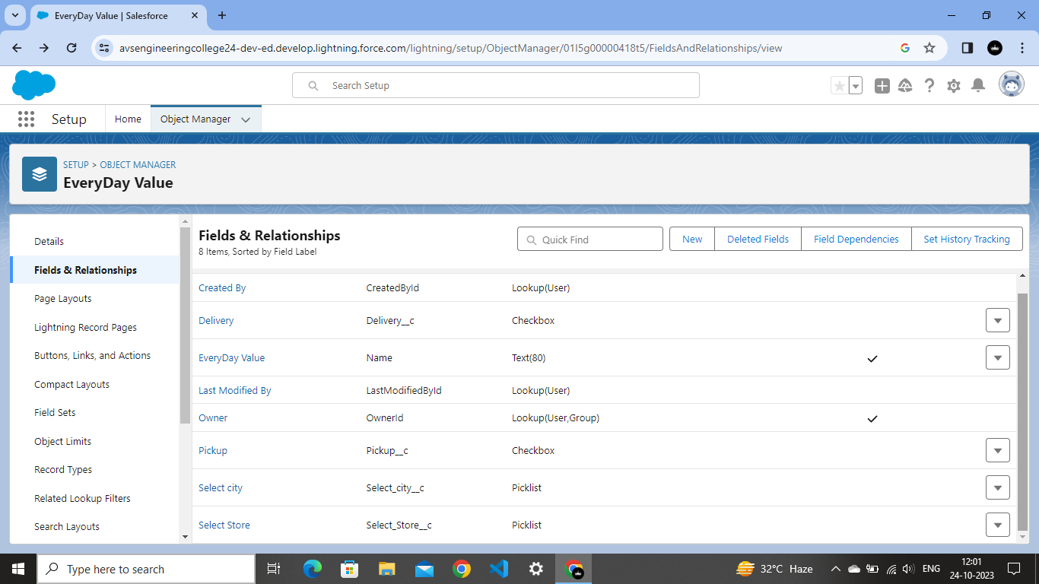**Fields in Consultants Objects**

**Click on new and create a new field as Crust**

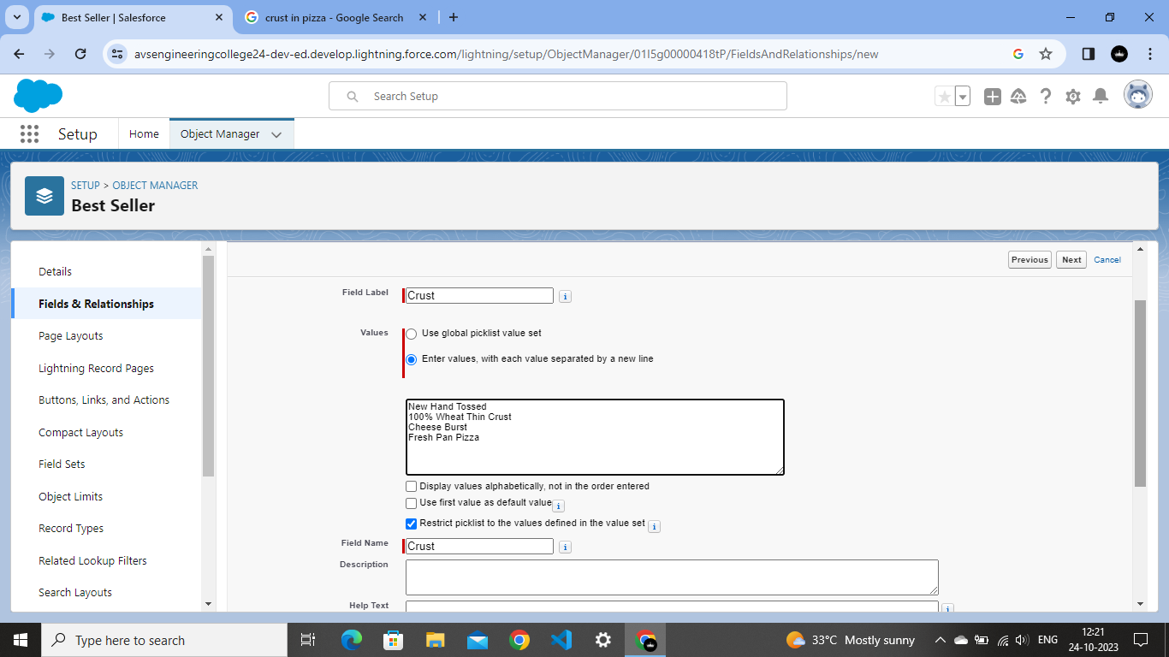

**Fields in Others Objects**

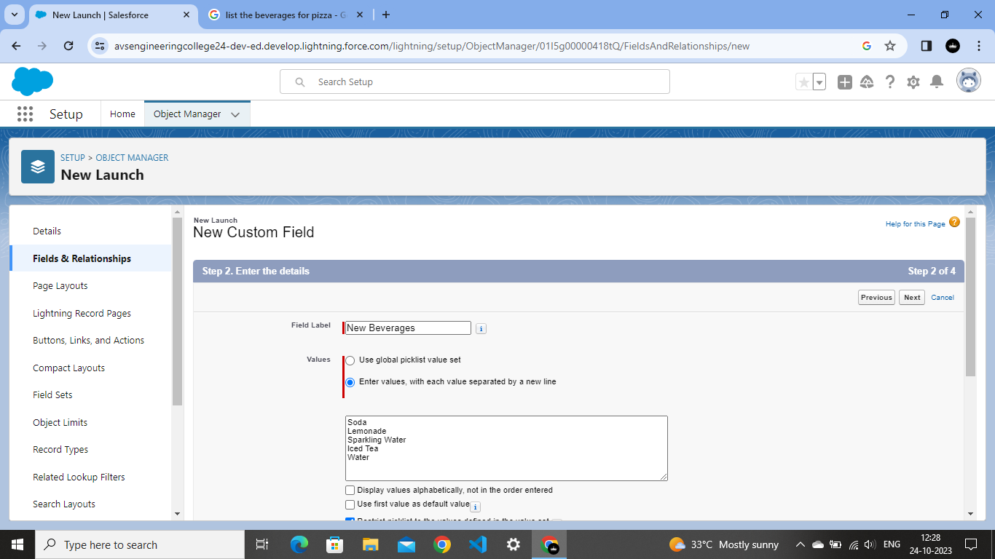

**Create a field as Types Of Pizzas**

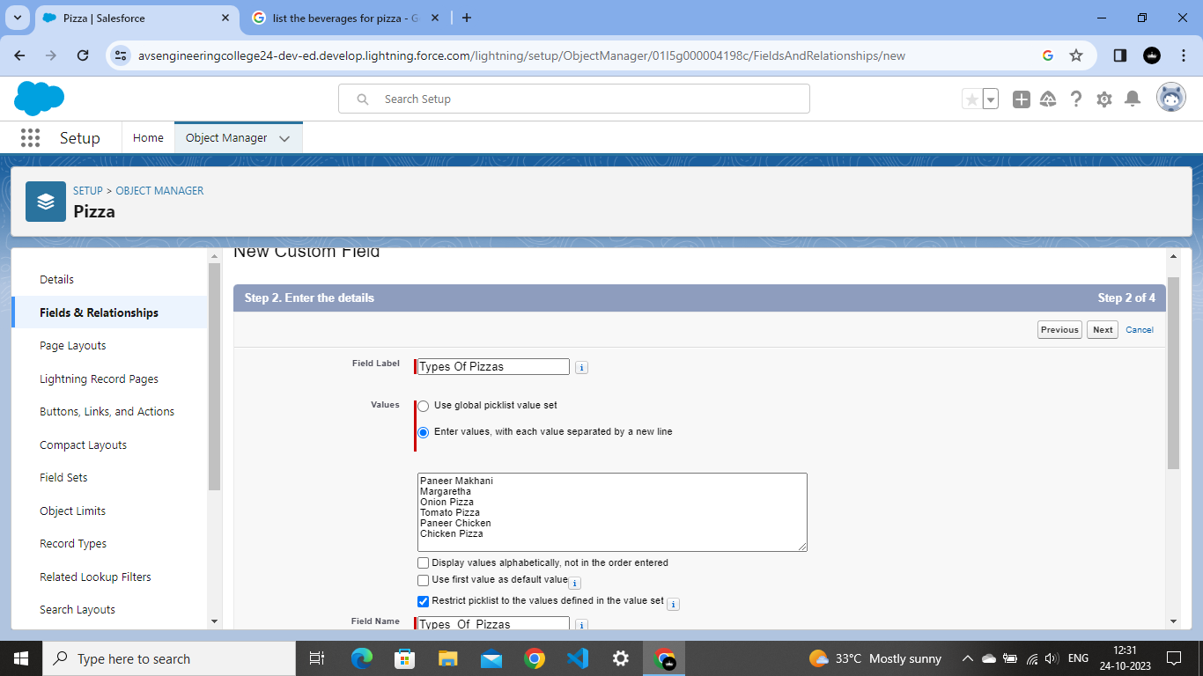

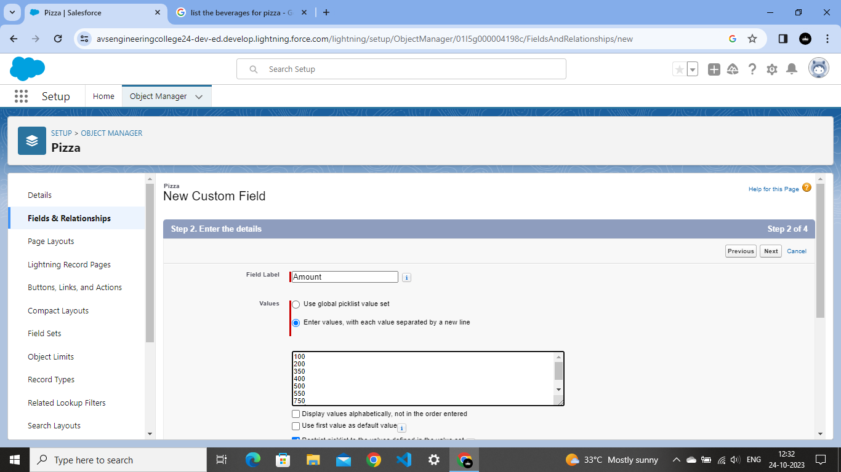

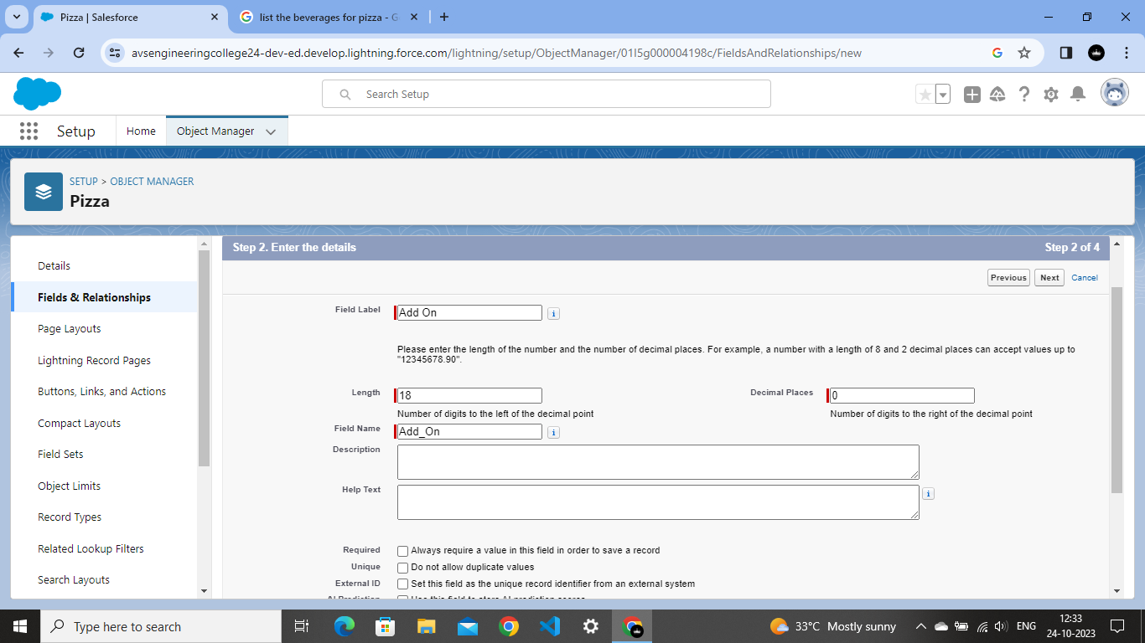

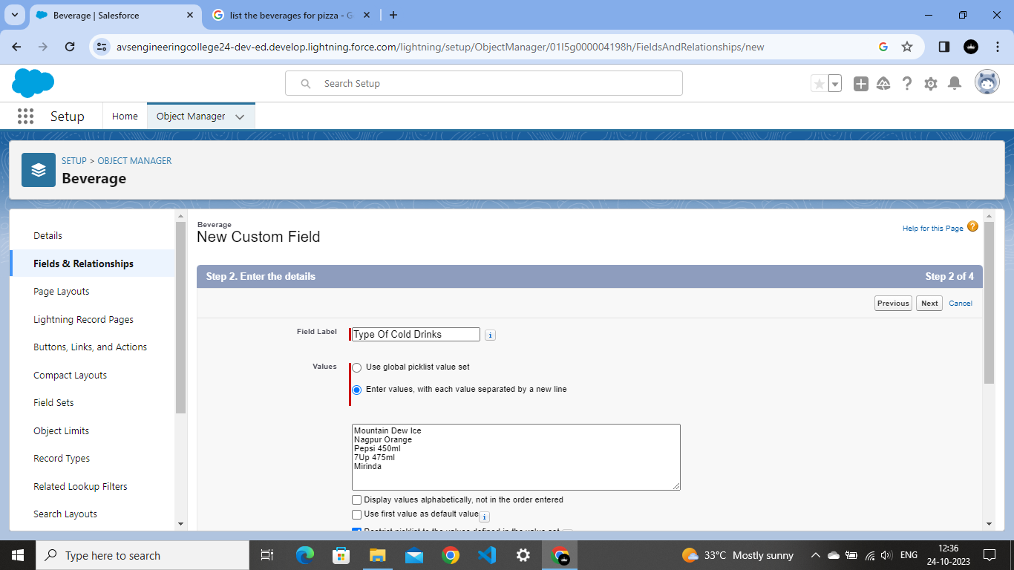

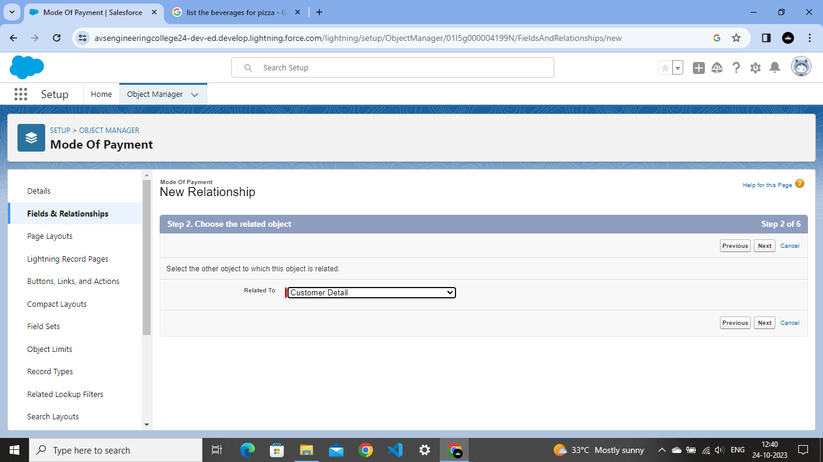

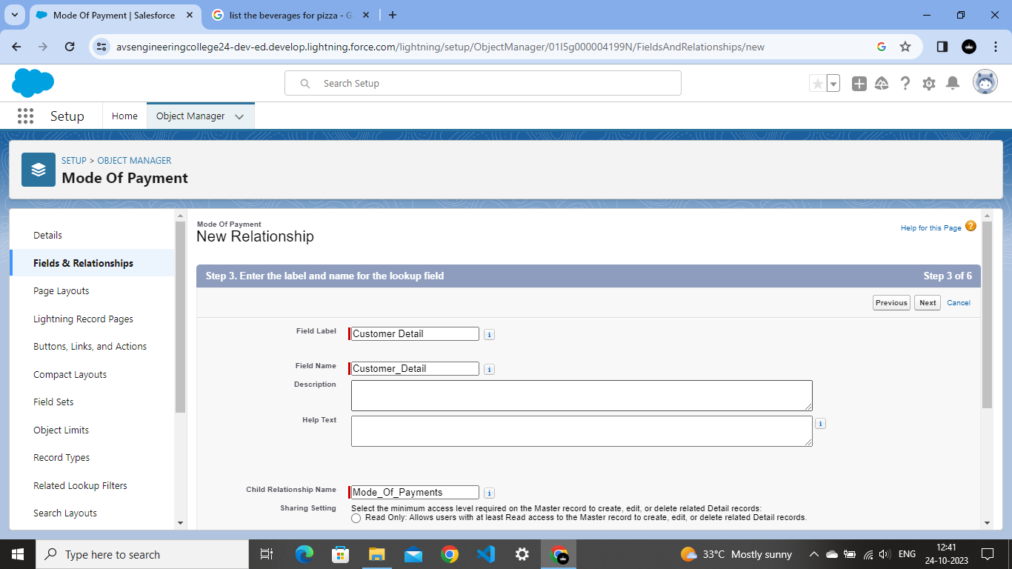

**2.6 Record Types**

Sales force Record Types are a way of grouping many records of one type for that object. These can be applied to any standard or custom object, and allow you to have a different page layout, fields, required fields, and pick list values.

**Go To Record Types and label name as Veg**

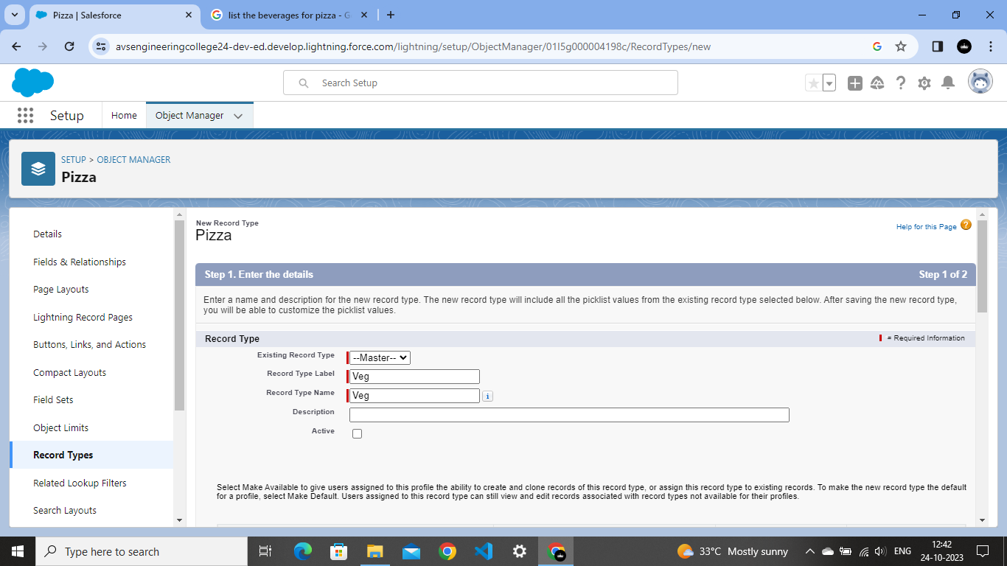

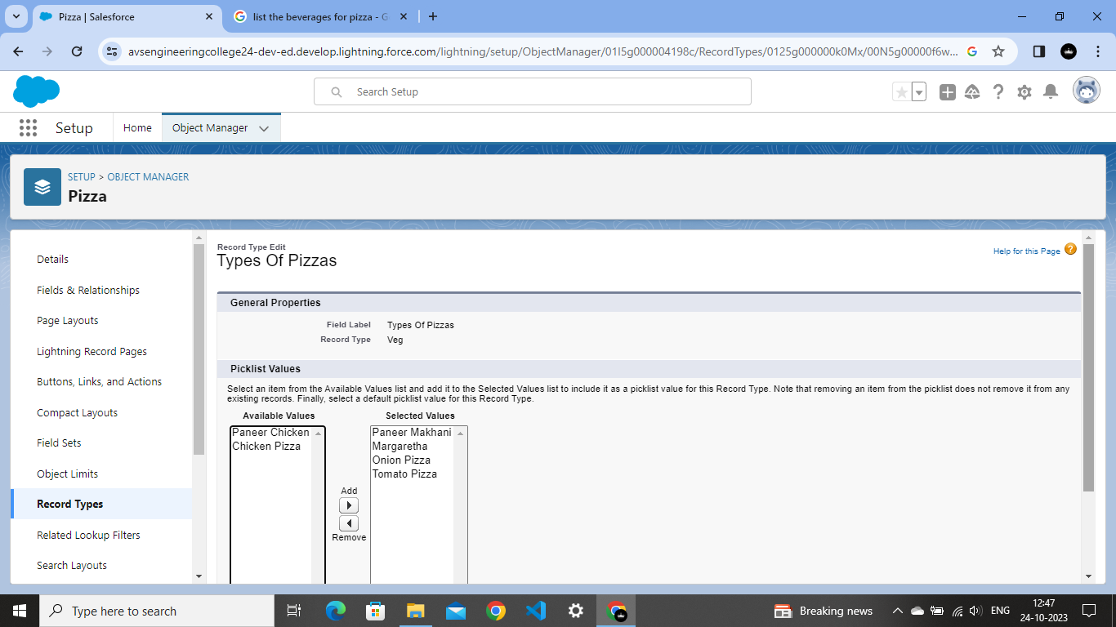

**CHAPTER-3**

**USERS & DATA SECURITY**

**3.1 Profile**

A profile is a group/collection of settings and permissions that define what a user can do in sales force. A profile controls “Object permissions, Field permissions, User permissions, Tab settings, App settings, Apex class access, Visualforce page access, Page layouts, Record Types, Login hours & Login IP ranges”.

**Creating a Profiles**

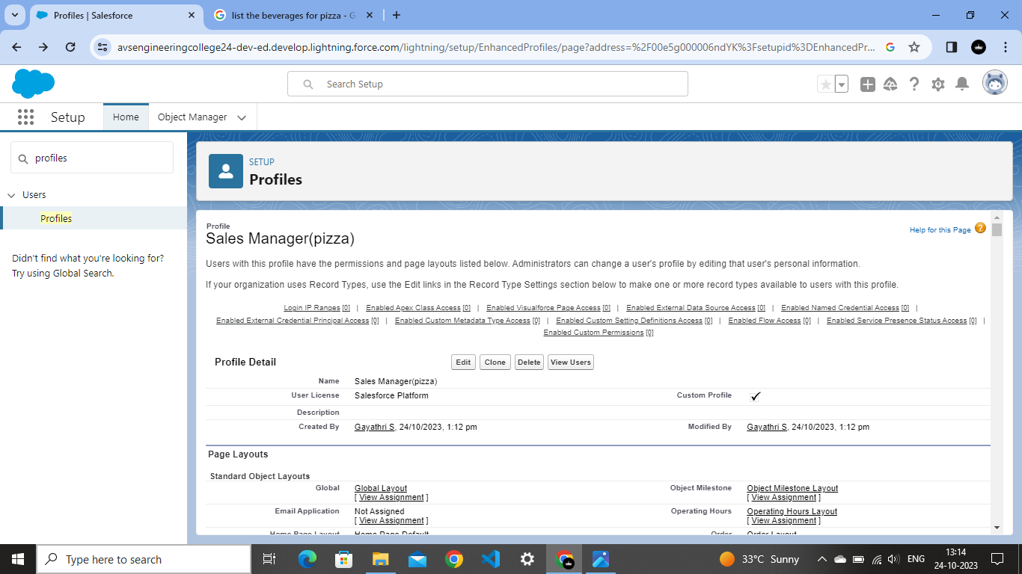

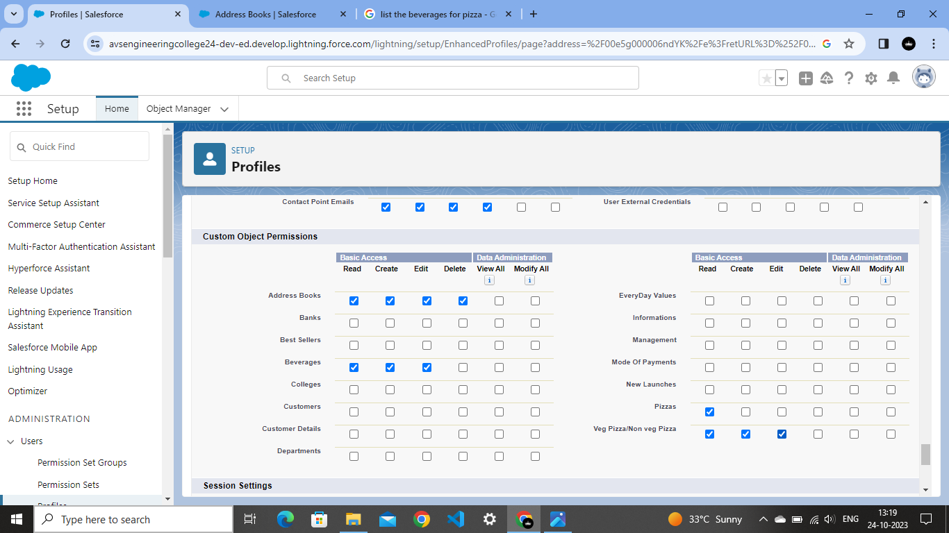

**Click on the read/create/edit/delete**

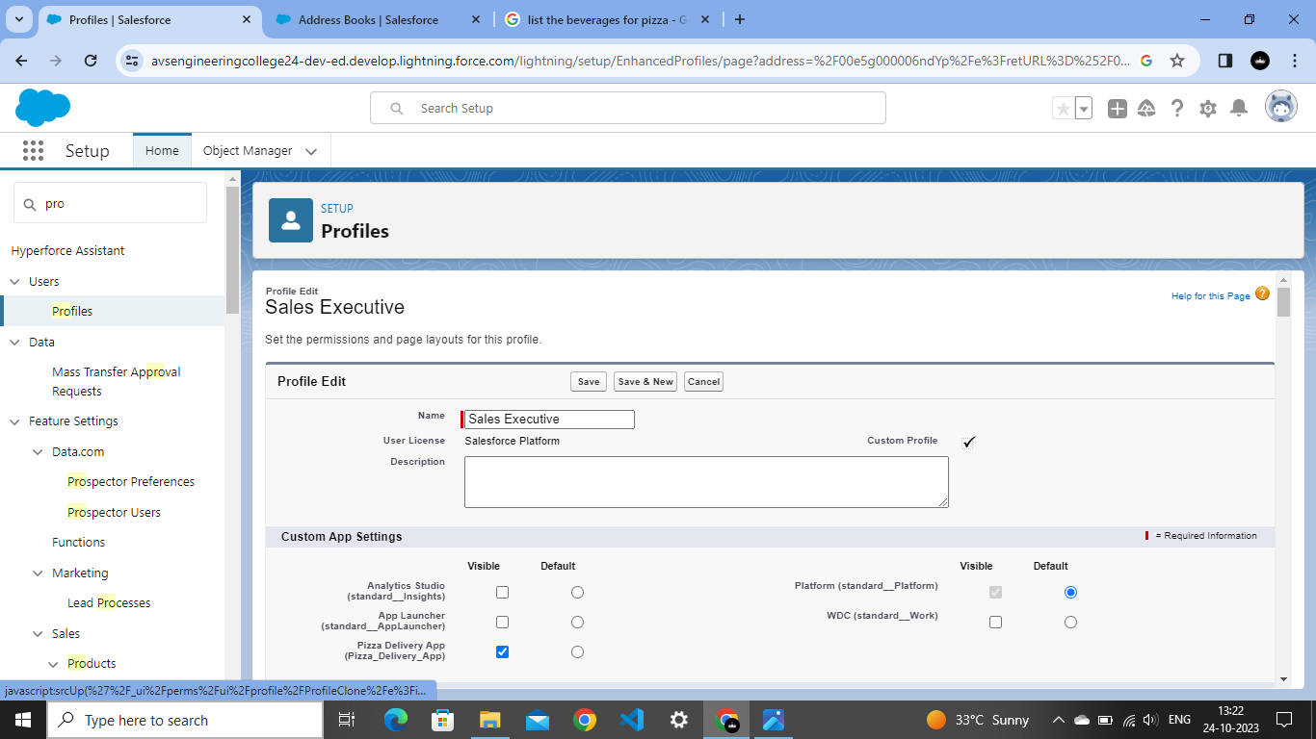

**Create a new profile as Delivery Person**

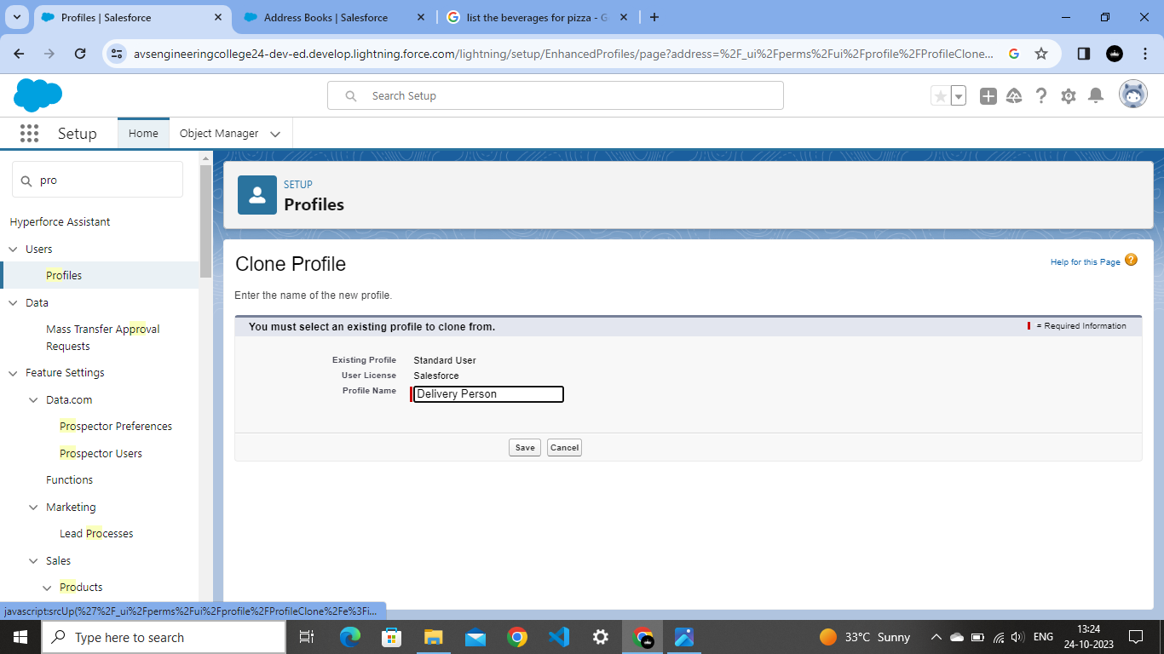

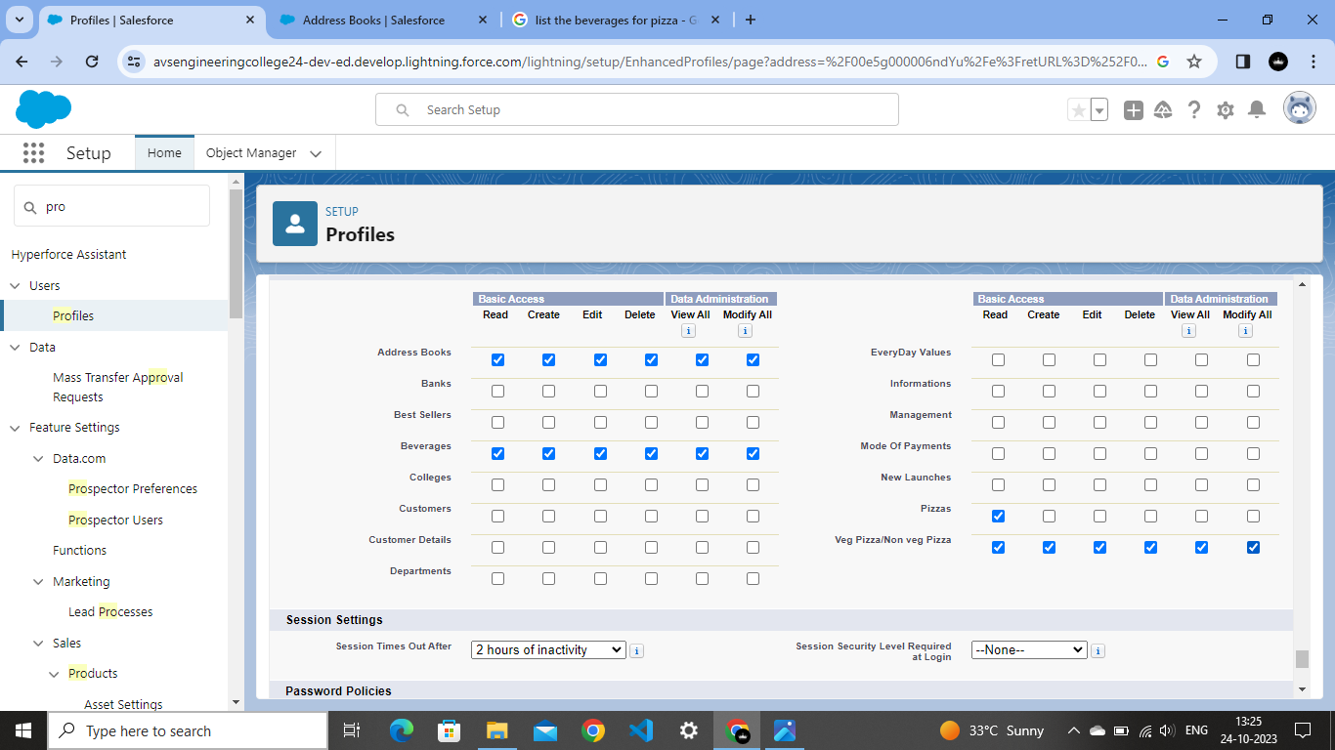

**3.2 User Adoption & Approval**

As a new administrator, you perform user management tasks like creating and editing users, resetting passwords, granting permissions, configuring data access, and much more.

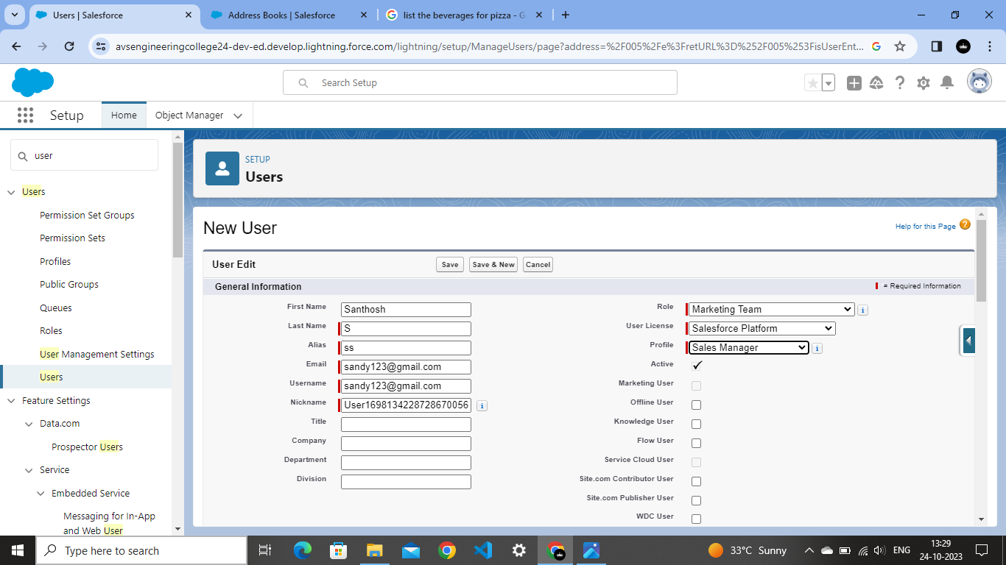

**CHAPTER-4**

**AUTOMATION**

**4.1 OWD**

Organization-Wide Defaults, or OWDs, are the pattern security rules that you can follow for your Salesforce instance. Organization Wide Defaults are utilized to confine who can access what information in your CRM

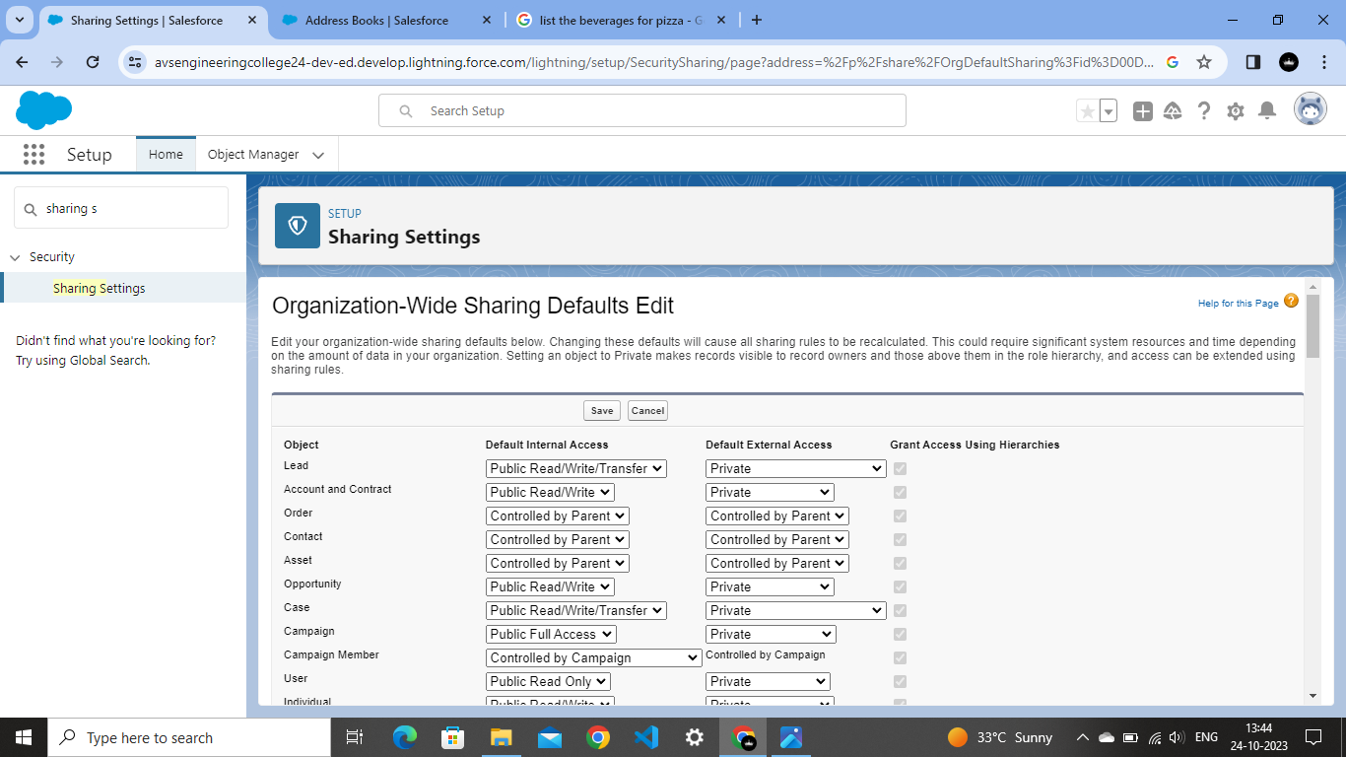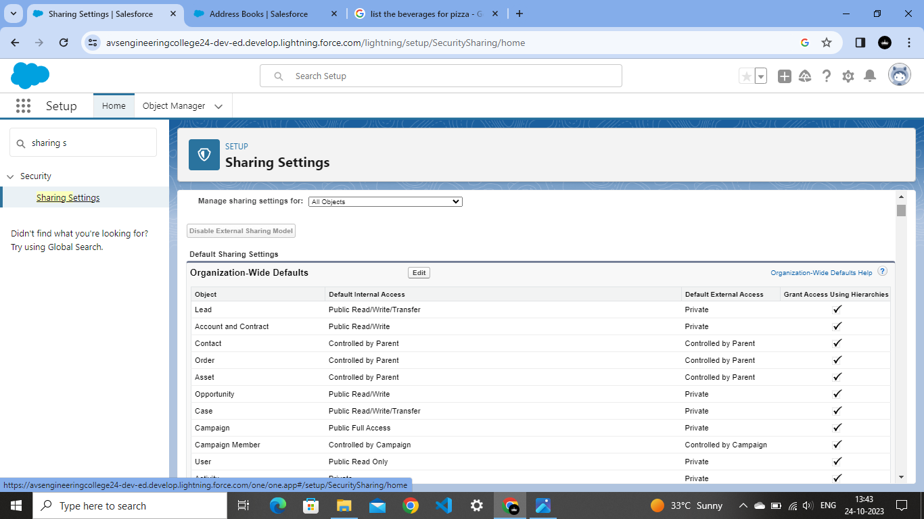

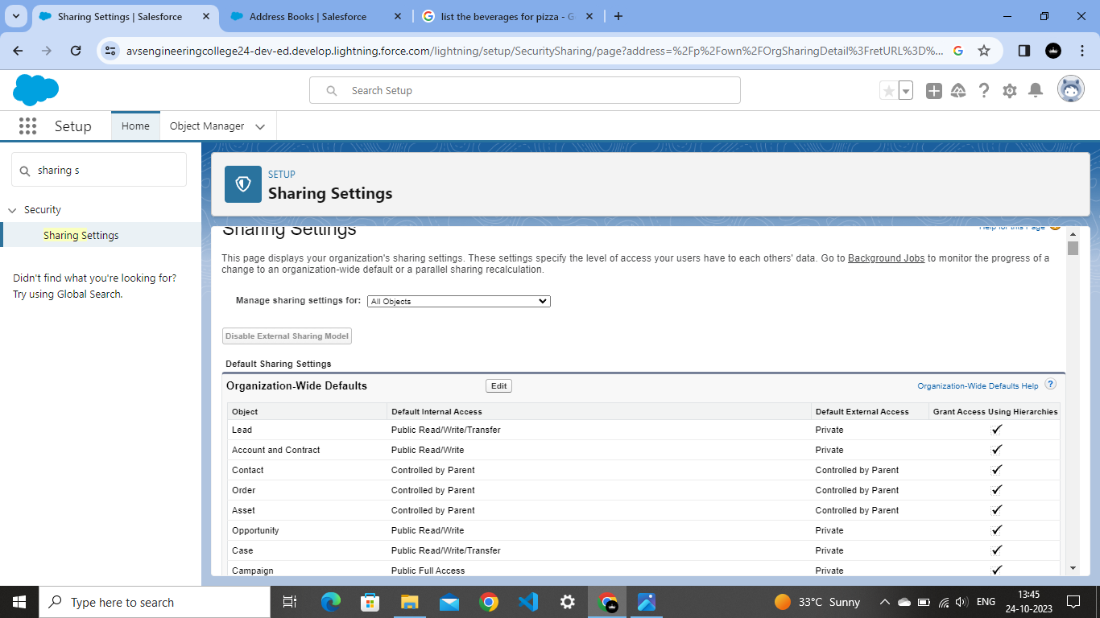

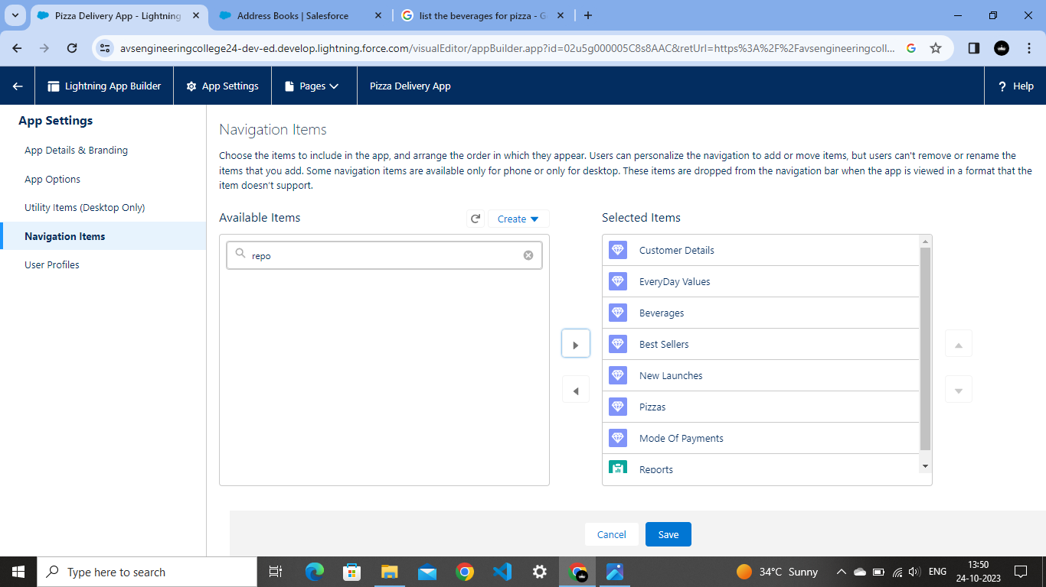

**4.2 Apex Trigger**.

Apex triggers enable you to perform custom actions before or after changes to Sales force records, such as insertions, updates, or deletions.

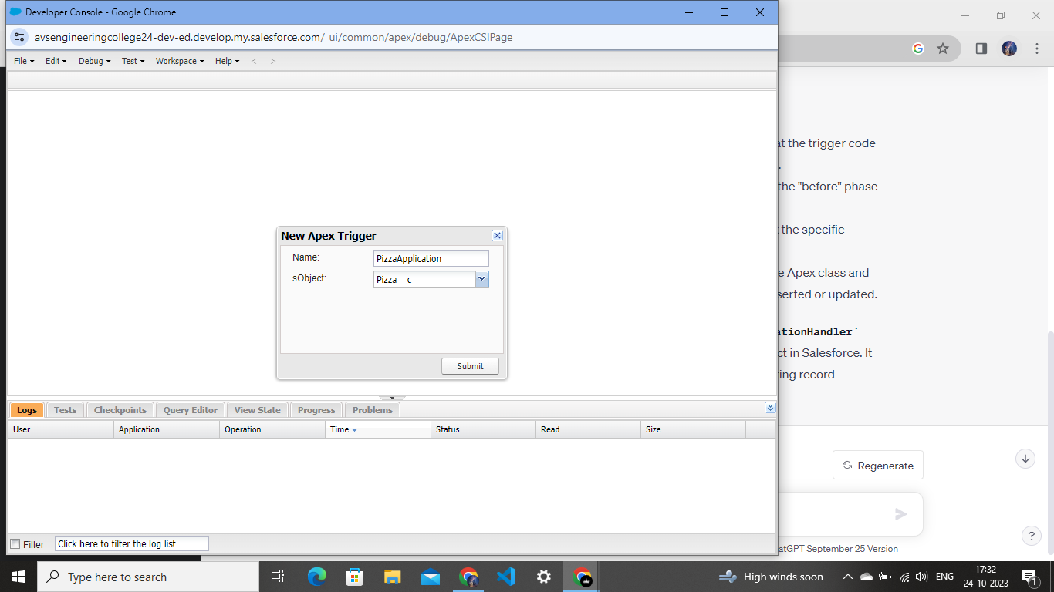

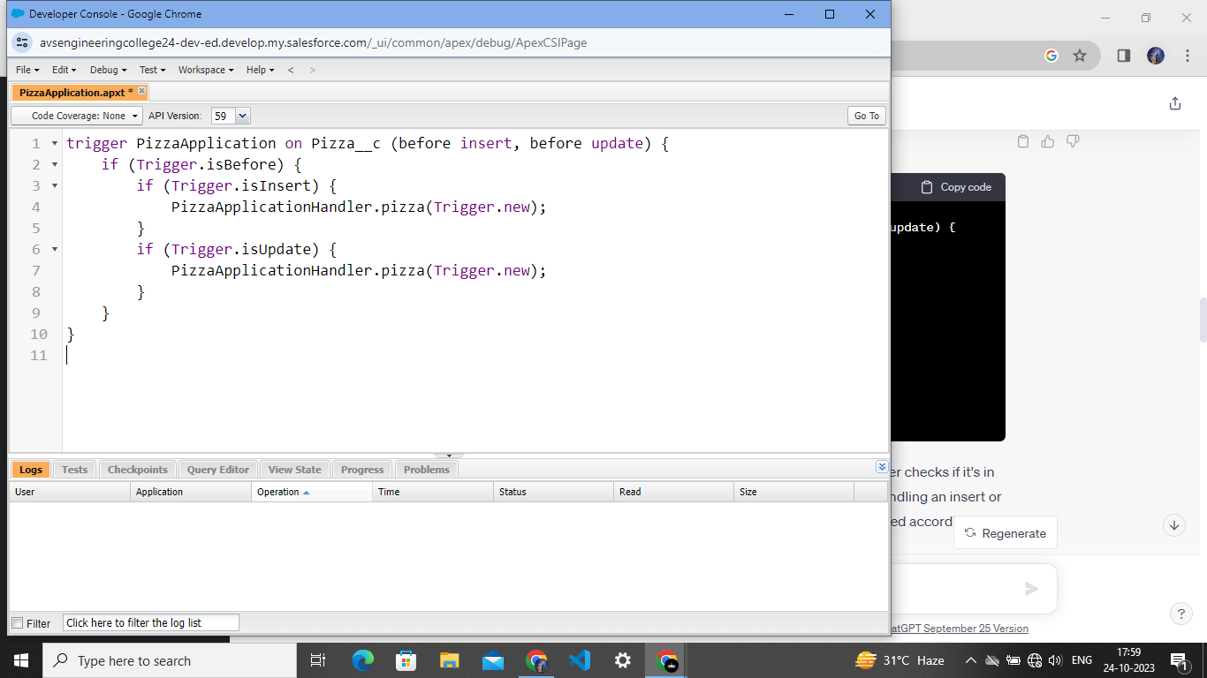

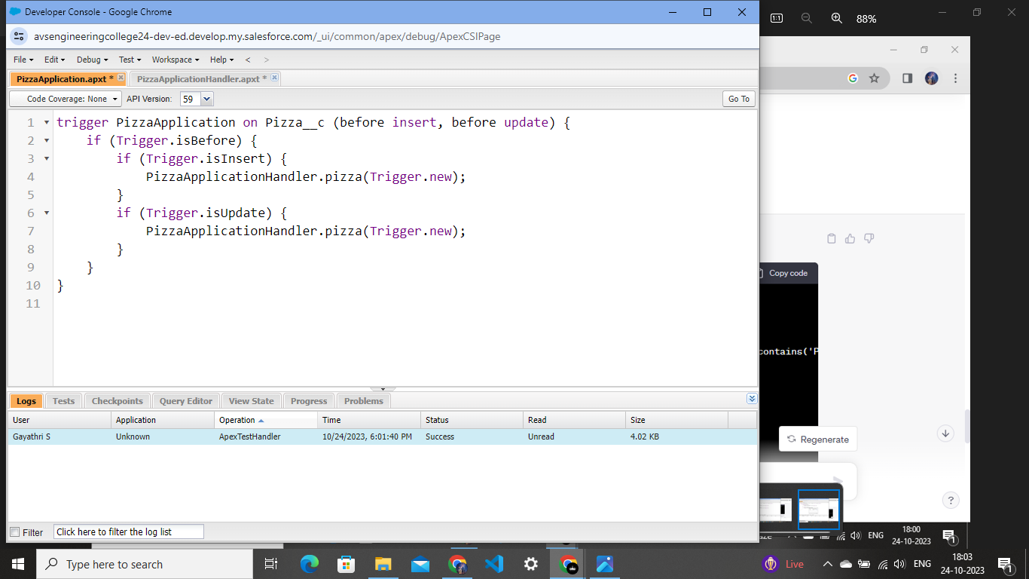

**4.3 Schedule Apex**

Scheduled Apex in Sales force is a feature that allows you to schedule the execution of Apex classes to run at specified times. This capability is useful for automating repetitive tasks, such as data updates or calculations, on a regular basis. 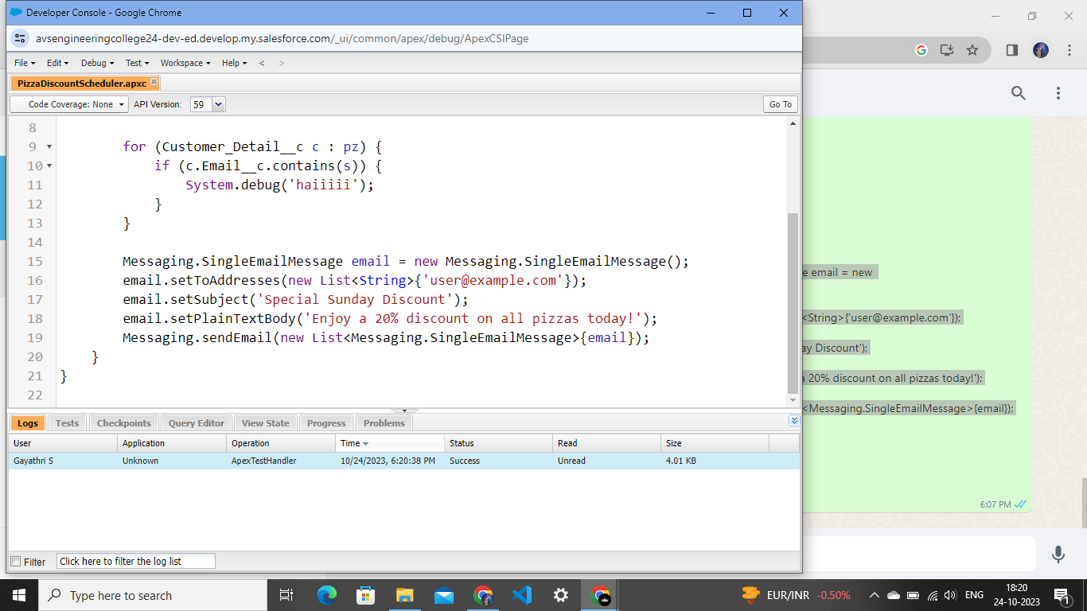

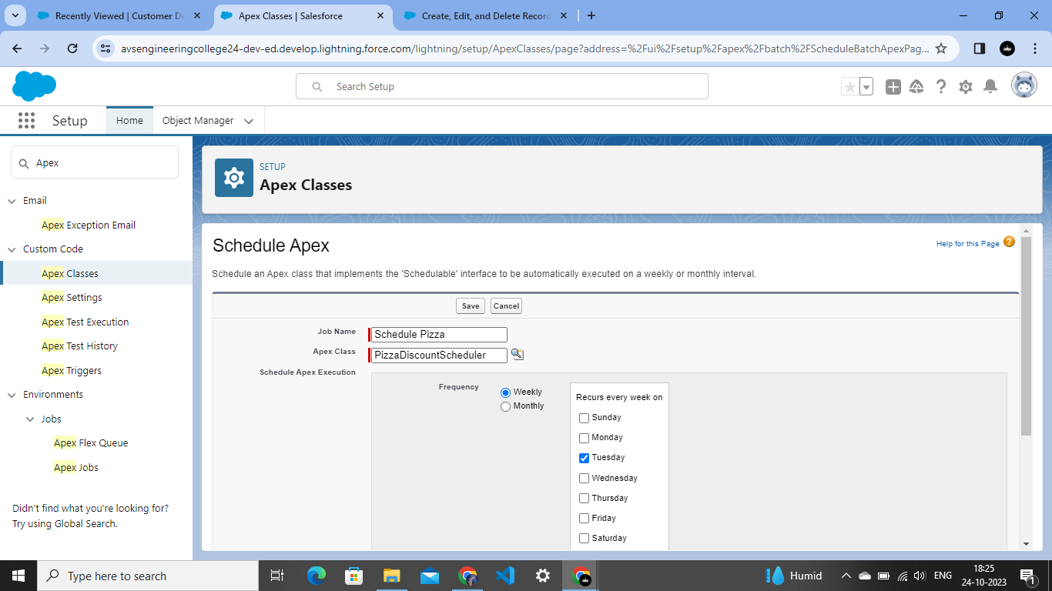

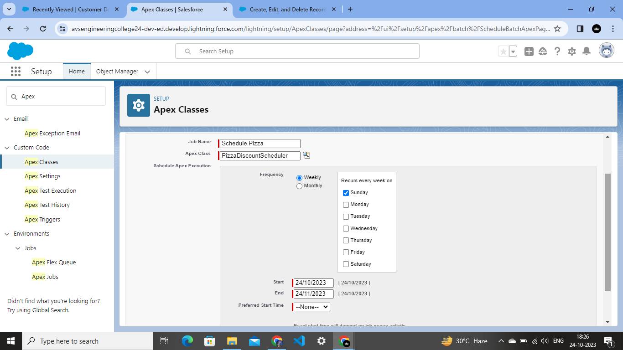

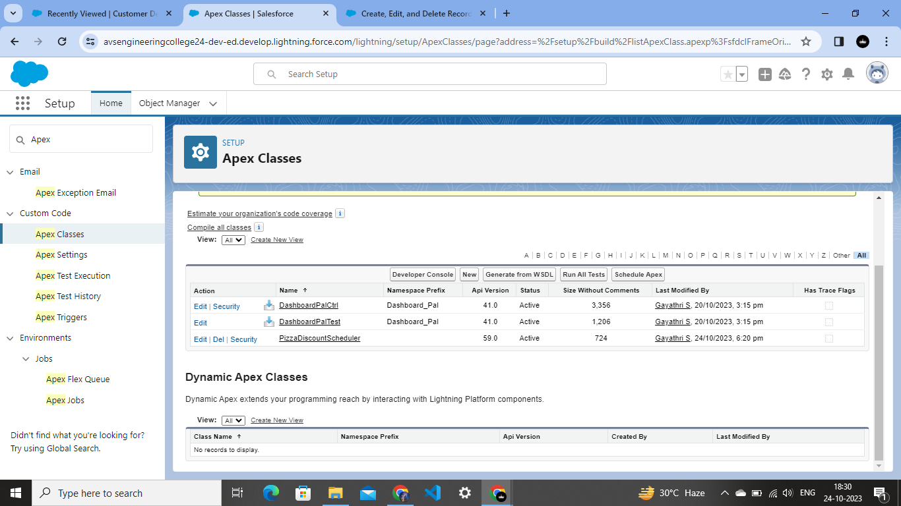

**CHAPTER-5**

**REPORTS & DASHBOARD**

**5.1 Reports**

A Salesforce report is a list of data generated based on filter criteria. Salesforce Reports helped us predict trends and gives us the advantage to increase profits. The report builder provides a drag-and-drop interface to easily build and customize your reports

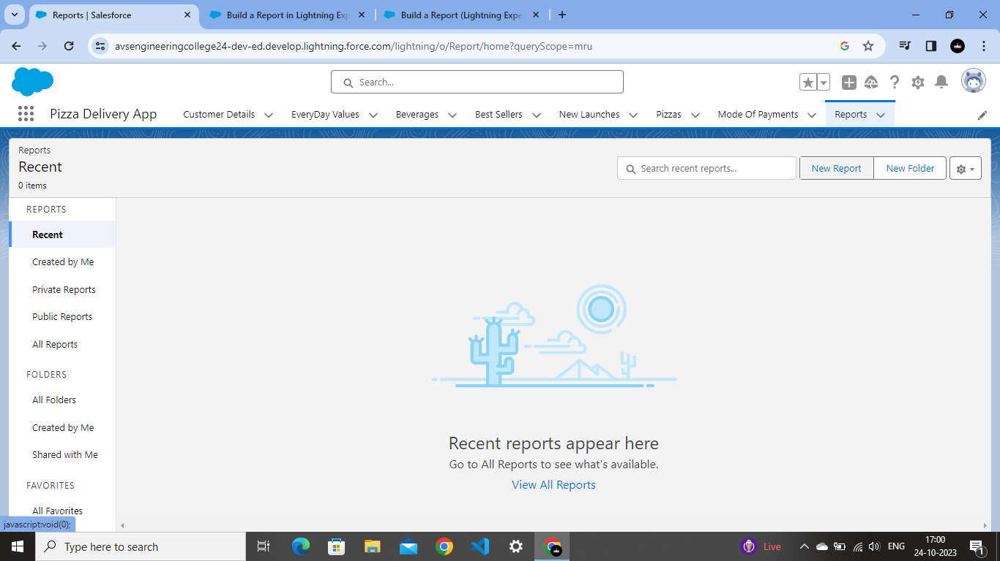

**Select the following option for the Rows and column**

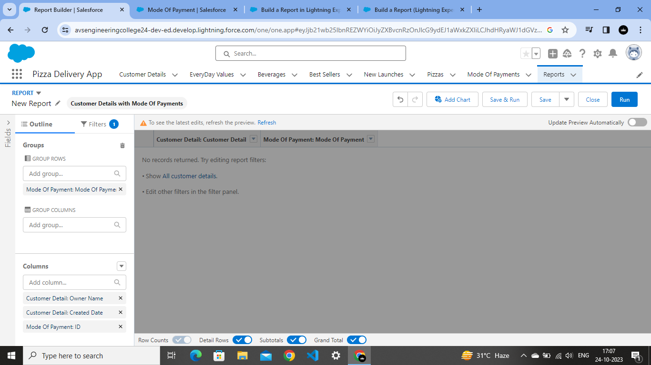

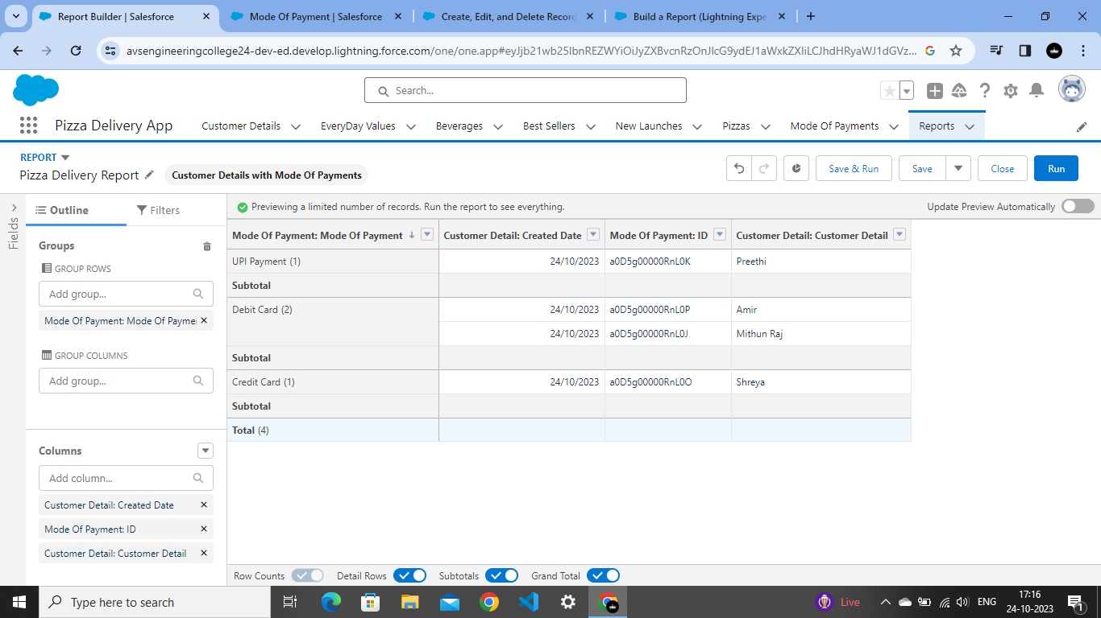

**You can  create the chart as so just click on the chart and you will be able to create it**

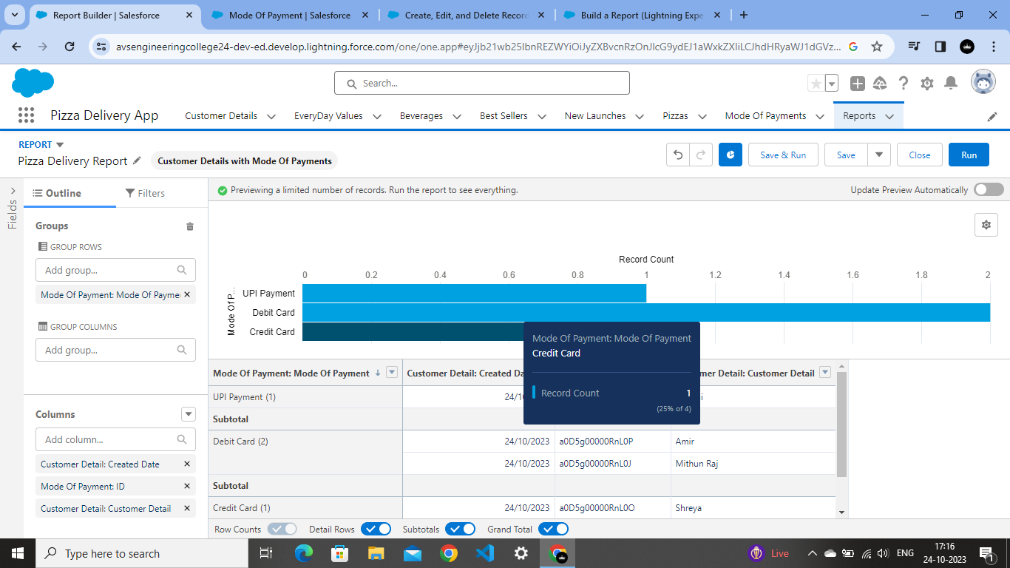

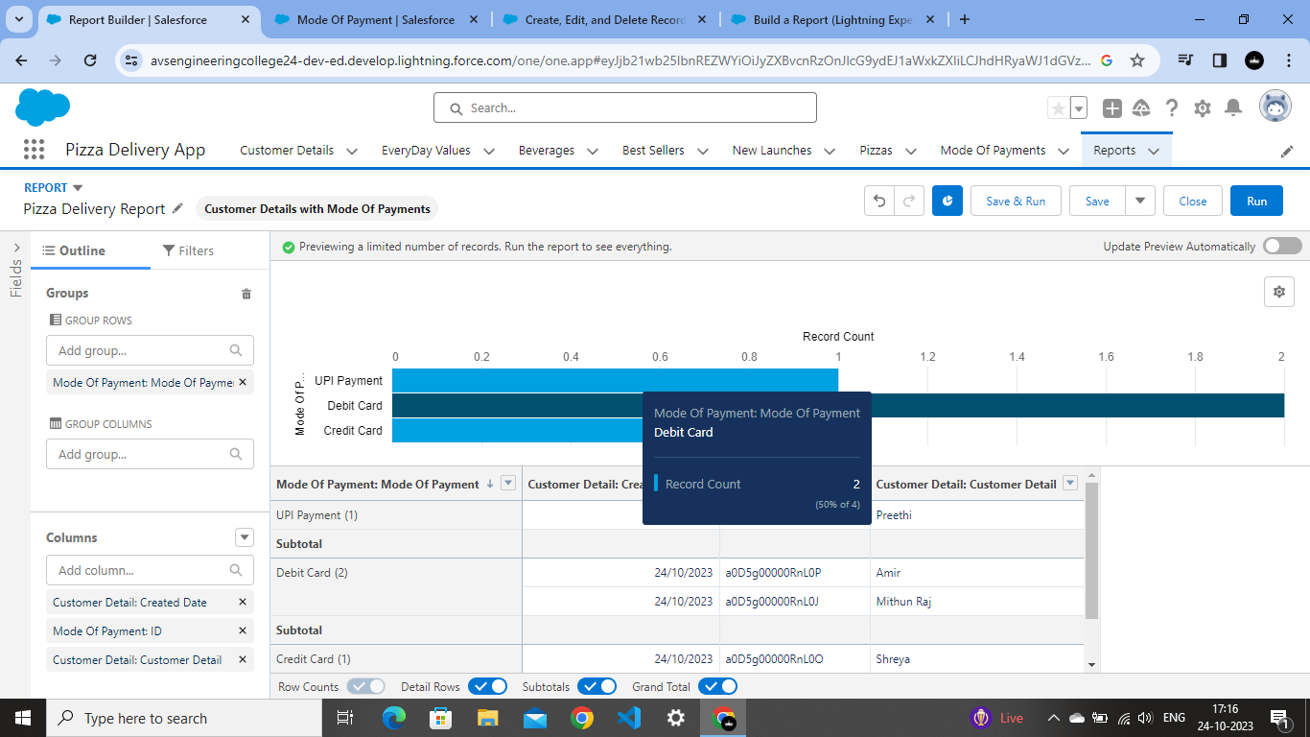

**CHAPTER-6**

**CONCLUSION**

In conclusion, the development and implementation of the pizza delivery app project represent a significant step forward in the realm of digital service platforms. Through meticulous planning, innovative design, and seamless execution, our team has successfully created a user-friendly, efficient, and reliable solution tailored to meet the modern customer's needs.

The app's intuitive interface and robust functionality streamline the ordering process, providing users with a hassle-free experience from start to finish. By integrating real-time tracking features, we have enhanced transparency and communication between customers and delivery personnel, ensuring timely deliveries and increasing customer satisfaction.

Furthermore, the incorporation of secure payment gateways and stringent data protection measures guarantees a safe and trustworthy transaction environment for both customers and the business. This focus on security is vital in establishing trust and credibility, fostering long-term relationships with our user base.

The project's success not only lies in its technical prowess but also in its ability to adapt and evolve. Continuous feedback loops and agile development methodologies have allowed us to address user concerns promptly and implement necessary updates, ensuring the app remains relevant and competitive in the ever-changing digital landscape.

Looking ahead, it is essential to continue monitoring user feedback, market trends, and technological advancements. By staying proactive and responsive to customer needs, the pizza delivery app can not only sustain its current user base but also attract new customers, driving growth and profitability for the business.

In essence, this pizza delivery app project showcases the power of technology in enhancing customer experiences and revolutionizing traditional business models. It stands as a testament to our team's dedication, creativity, and expertise. As we move forward, let this project serve as a foundation for future innovations, inspiring us to explore new horizons and create even more impactful solutions for the digital age.

**CHAPTER-7**

**PROJECT DEMONSTRATION**

**GitHub:**

<https://github.com/Gayathri2k3/Gayathri_2DE609BEACAAFDA93DC492429FF2BCB3>

**Demo Link:**

<https://drive.google.com/file/d/107w-97rdtufUmbCet815MY0q3P13Ay5g/view?usp=drivesdk>